Continuous Delivery 3

Working with Gates and Manual Intervention

Approval is human approval somebody who is a manager role responsible for approving/disapproving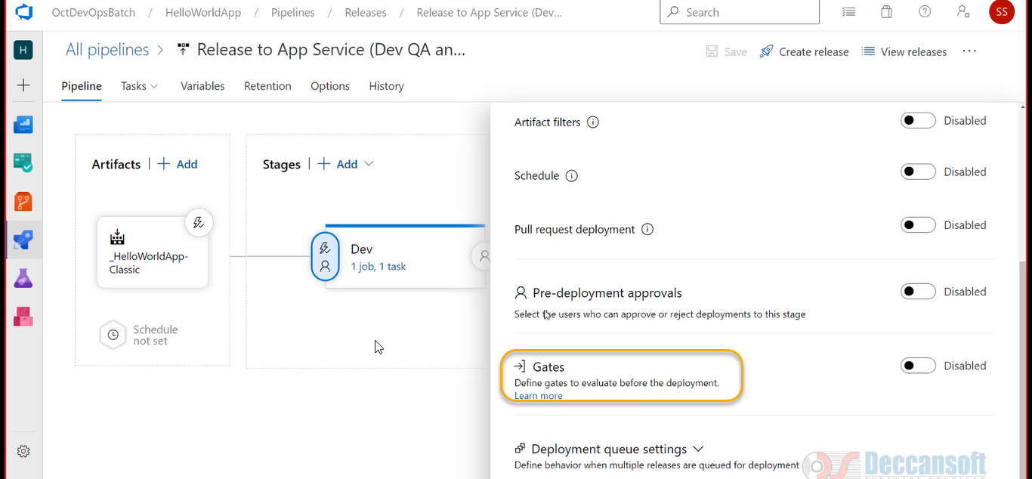

But we need an automated check to be performed

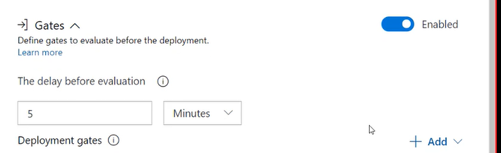

If you click on + Add with respective to above screenshot we can the types of gates

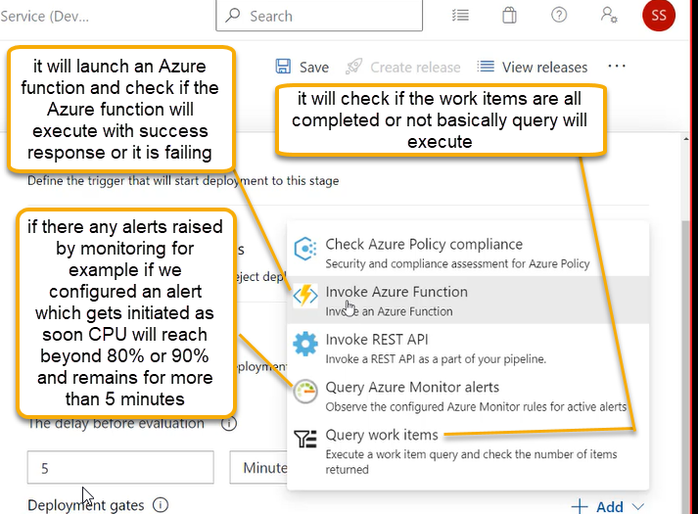

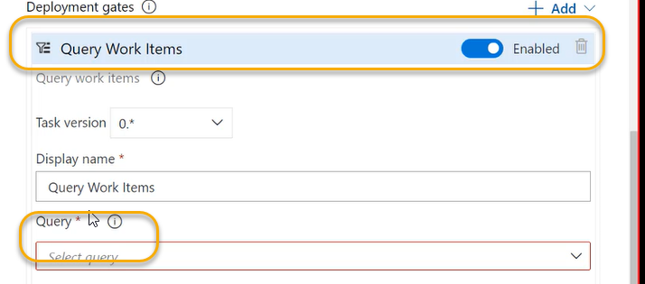

Now we need a query for that go to Azure Board



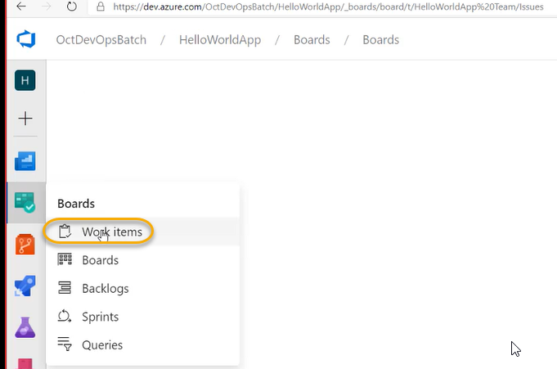

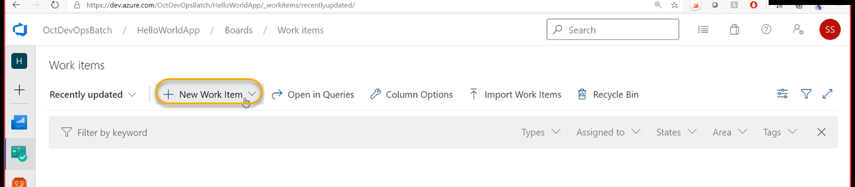

I want my deployment to be done for QA only if the pending issues are resolved that means they are marked as Done

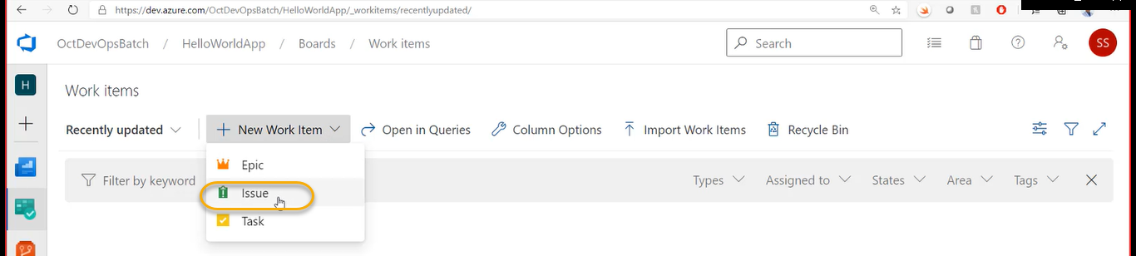

Every issue has stages like ToDo, resolved and Done and only if the stage is Done I want to probably deploy to QA

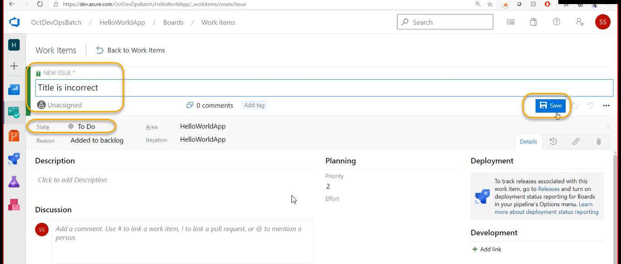

Whenever developer will pick this item he will check and make it will marked as Done

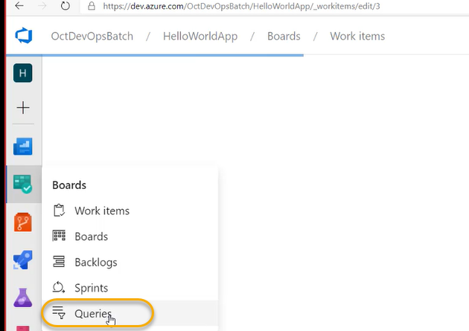

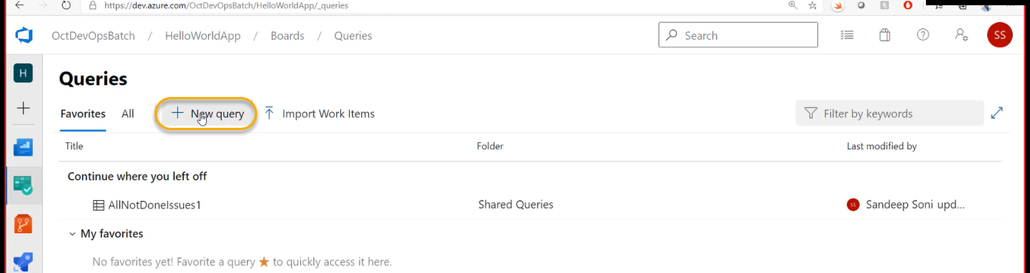

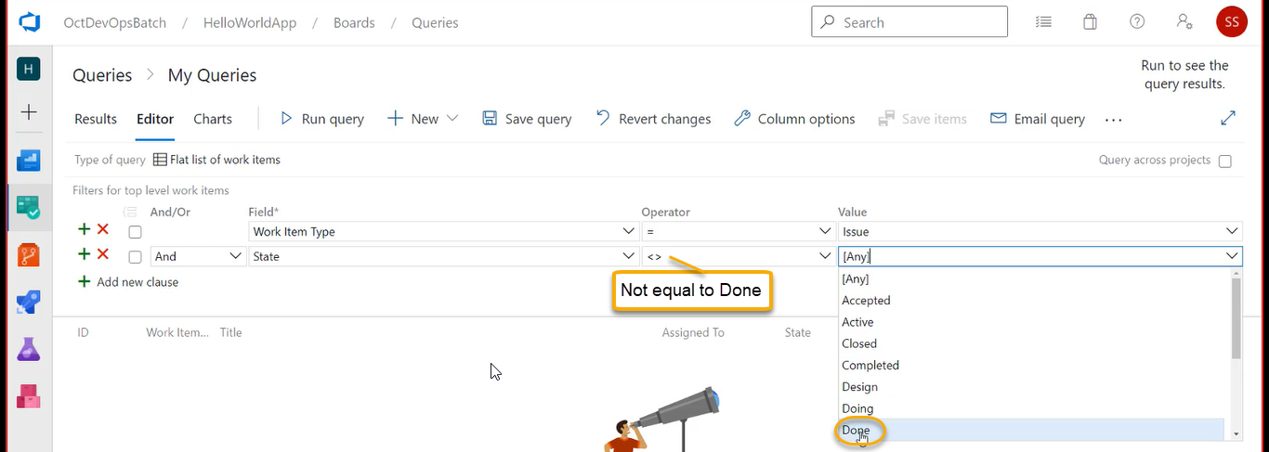

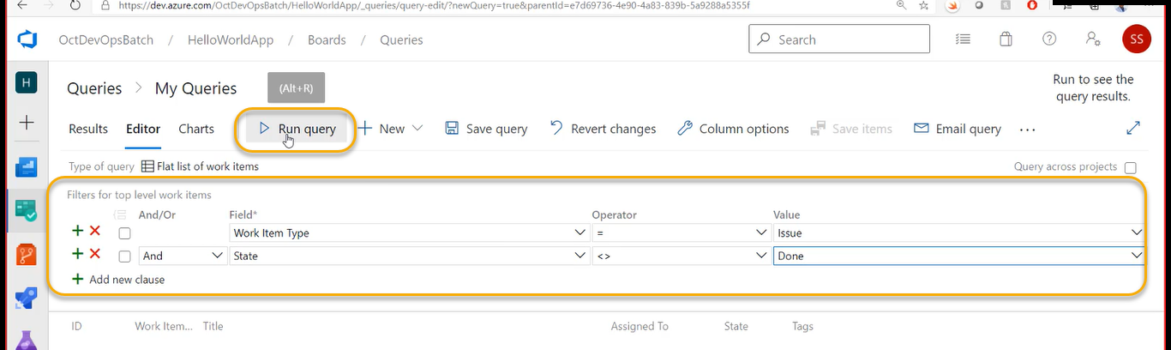

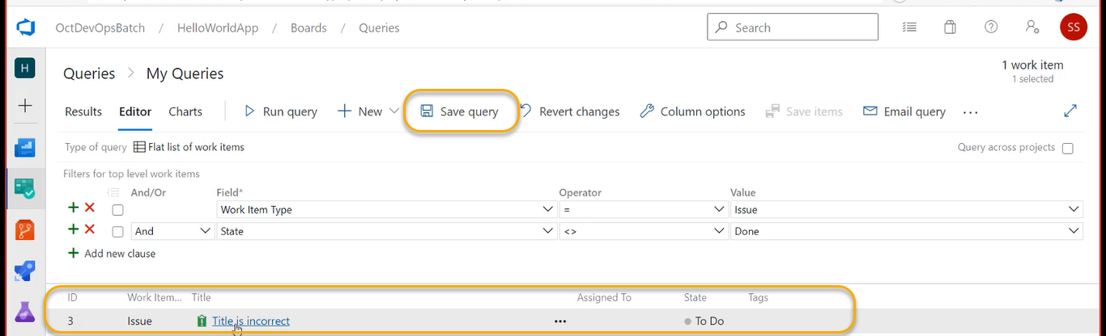

When want to use this Query in pipeline It should NOT be saved in personal Query

My query is visible to me only if login to Azure DevOps

Shared queries is visible to all who ever logins in

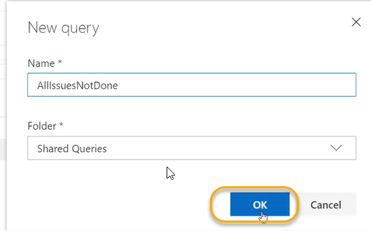

I need to build the gateway in a such way that if there is even one result of this particular query don’t want to deploy to QA. It should deploy to QA only the Query value returns to Zero

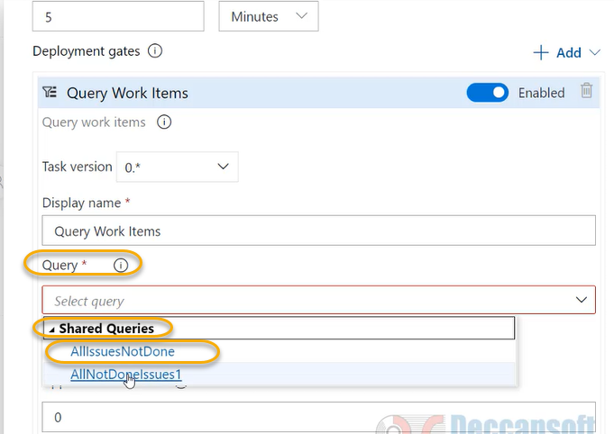

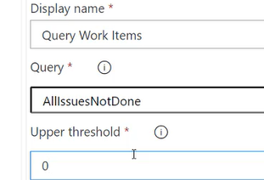

The upper threshold value may be we can give as 2( if ONLY two issues are NOT marked as Done)

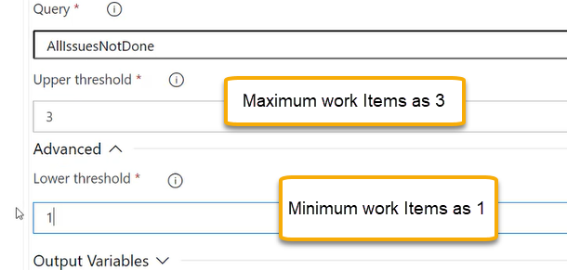

Before the gate is evaluated if we want add some delay ( probably the previous stage has done something and because of that it would take some time to actually adjust the environment I will give 1 minutes before the gate is evaluated but in the below screenshot the value is 5 change to one

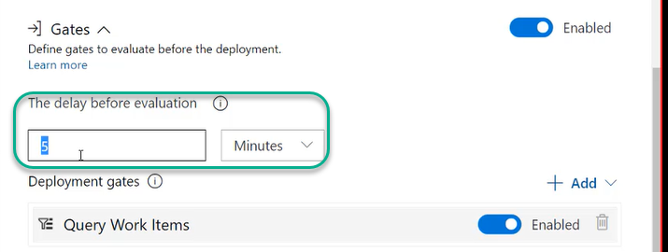

Once the Dev is completed and it will wait for 5 minutes and perform the Query Work Items

Or we can give in Hours

If the gate is failing how much time it requires to re-evaluate of gates

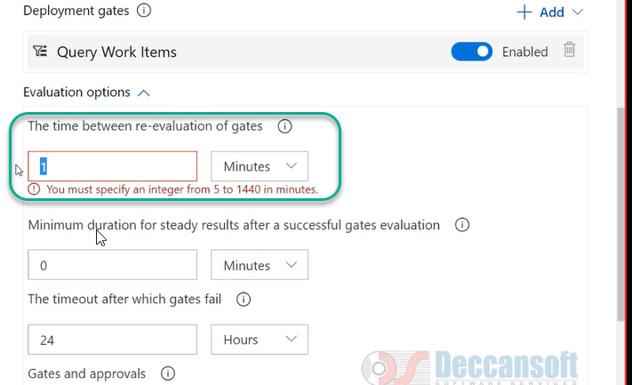

Gate is revaluated and before the task starts

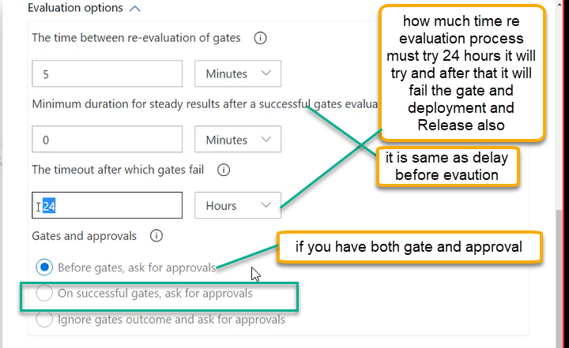

If you want to add one more gate

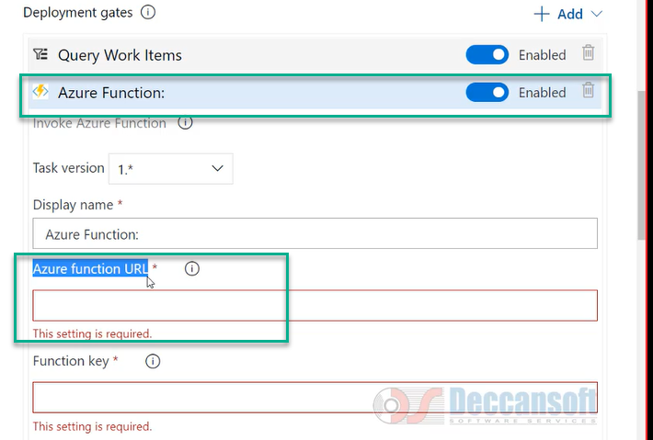

For Azure function URL: Go to Azure portal > write an Azure function > and then give the URL as highlighted above

And function is allowed to execute only for authenticated users you will be given one key that function key has to be mentioned

And that function you need post some data beside that which method

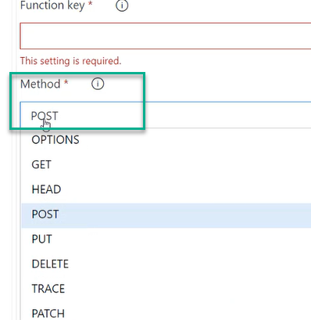

Which method you need to invoke the function

If you to send the form data we will put it in the Body

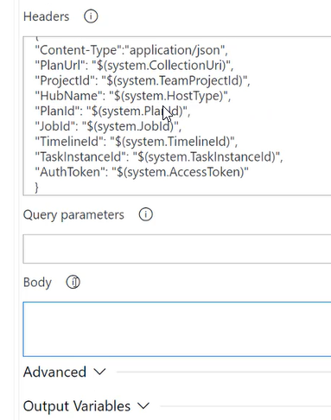

DevOps engineer will communicate with developers and write the function

A success message or fail message will come 200 series is a success and anything else is failure

If it is success, then the gate is opened and move into another deployment

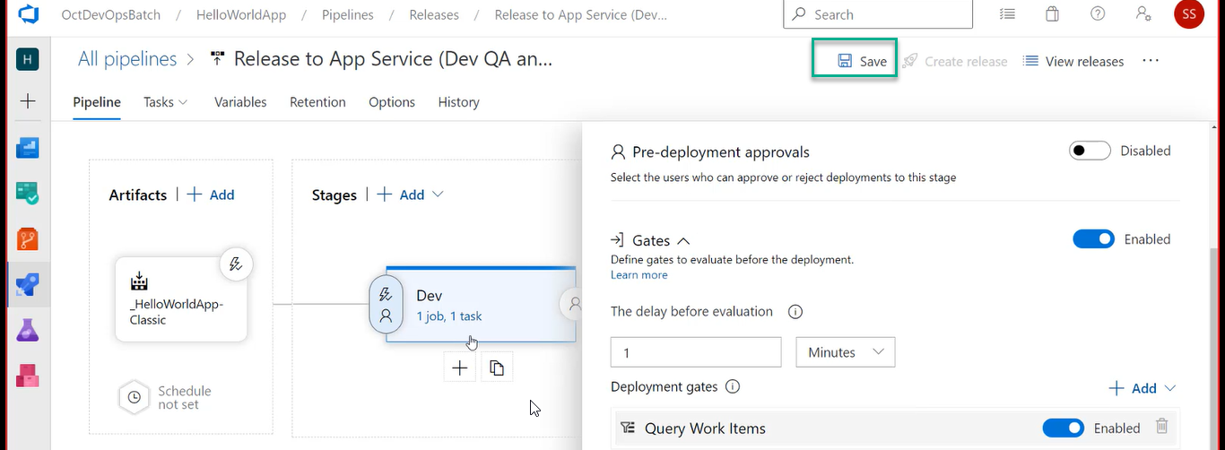

I have done for DEV and in real time we need to give the above procedure for QA

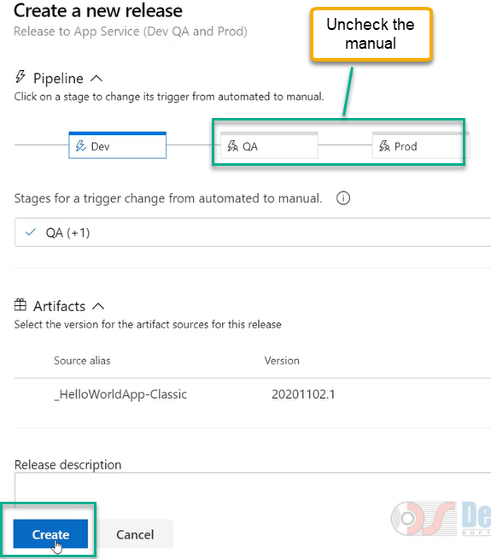

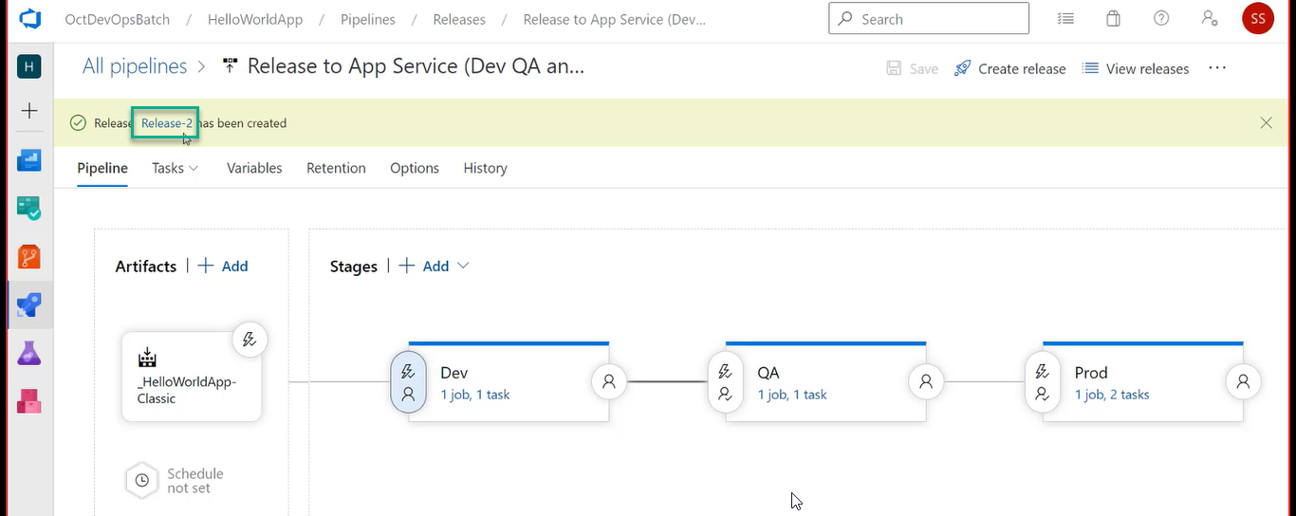

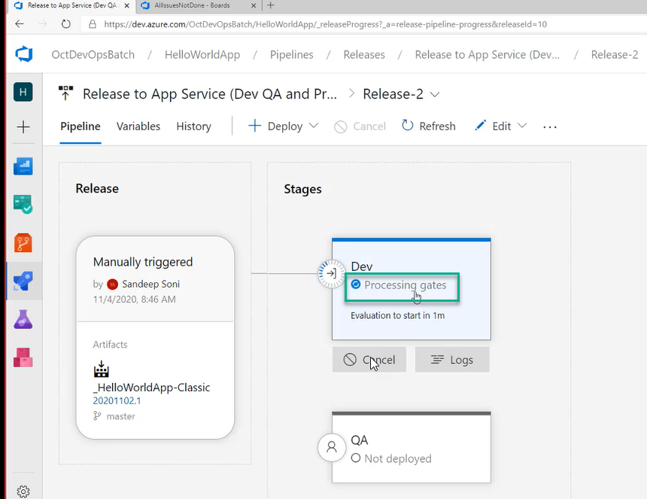

Click on the logs has shown above screenshot

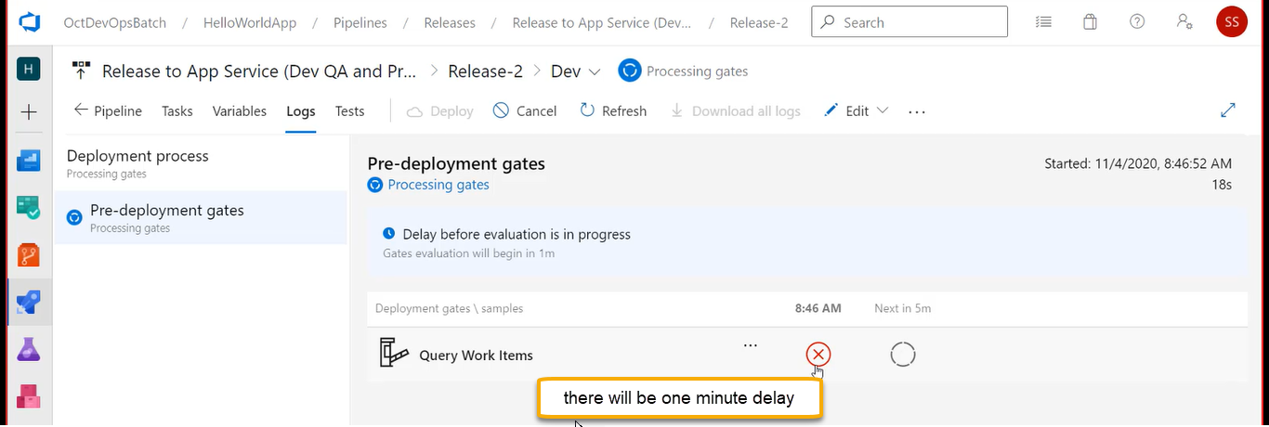

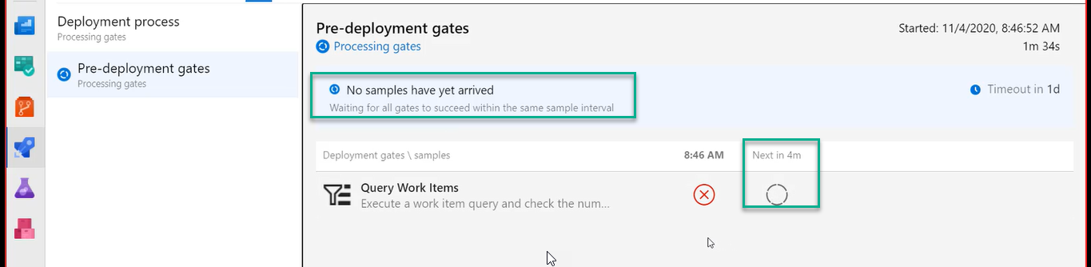

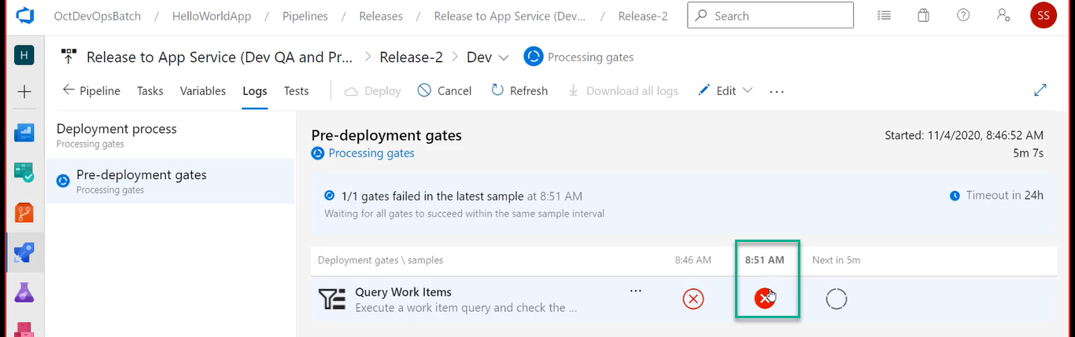

Again, it is failing

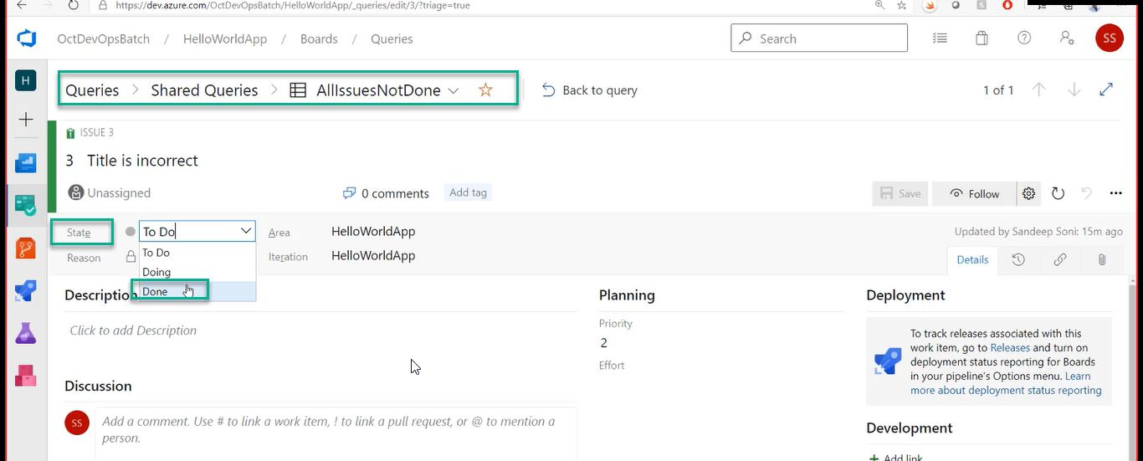

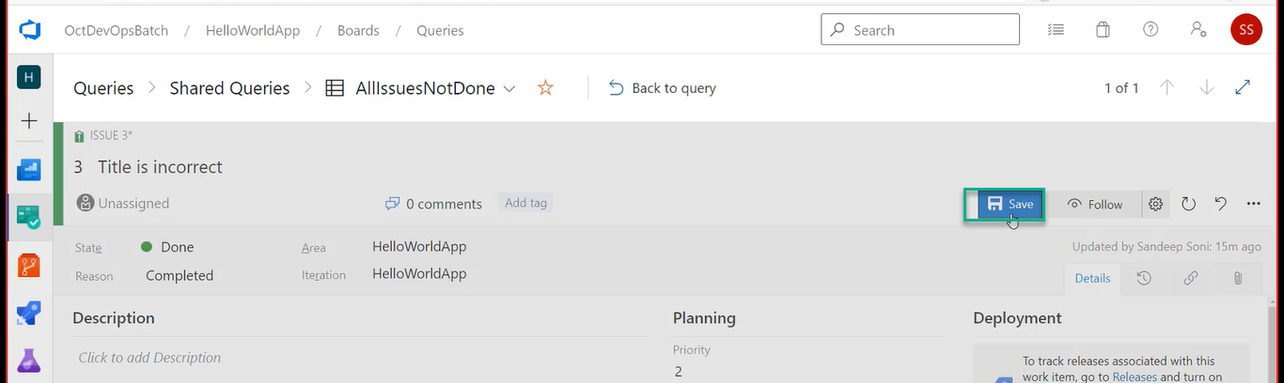

And we see NO records in Query

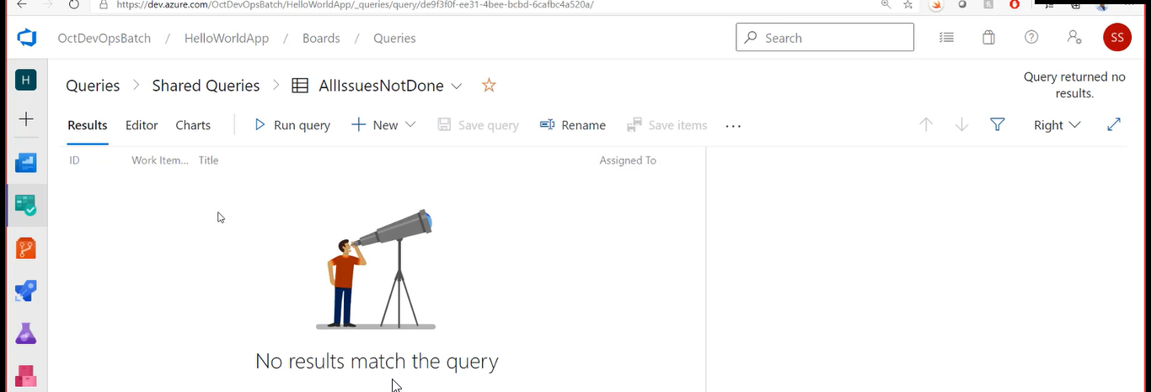

If you are doing in YAML go to the below steps

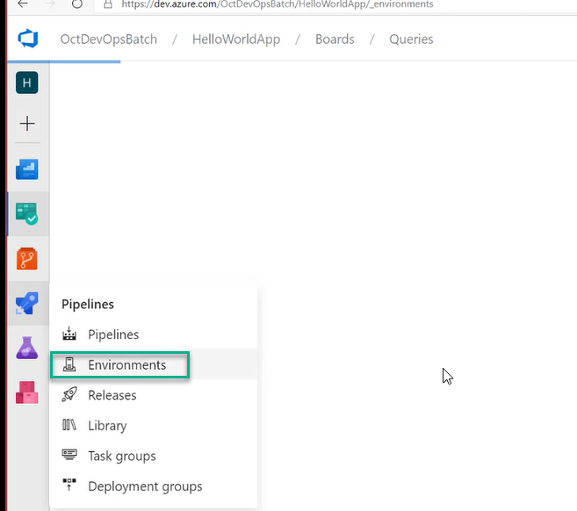

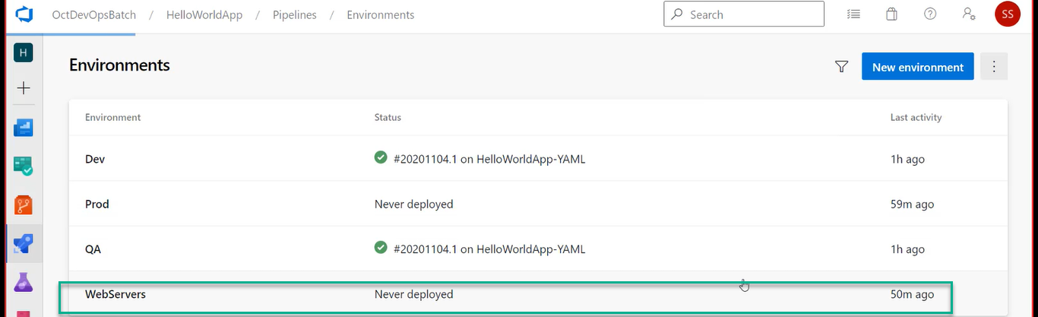

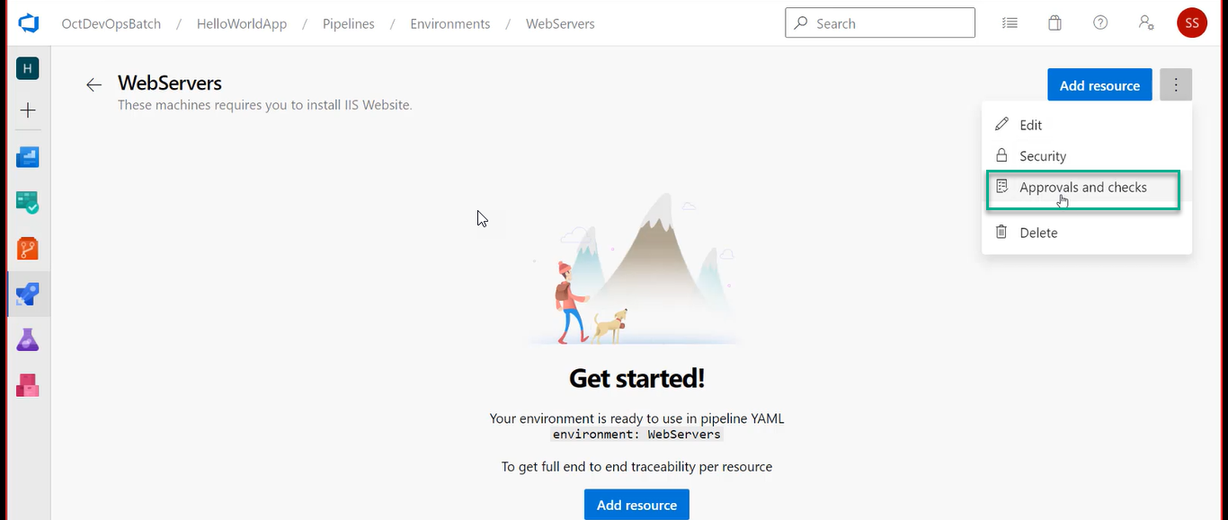

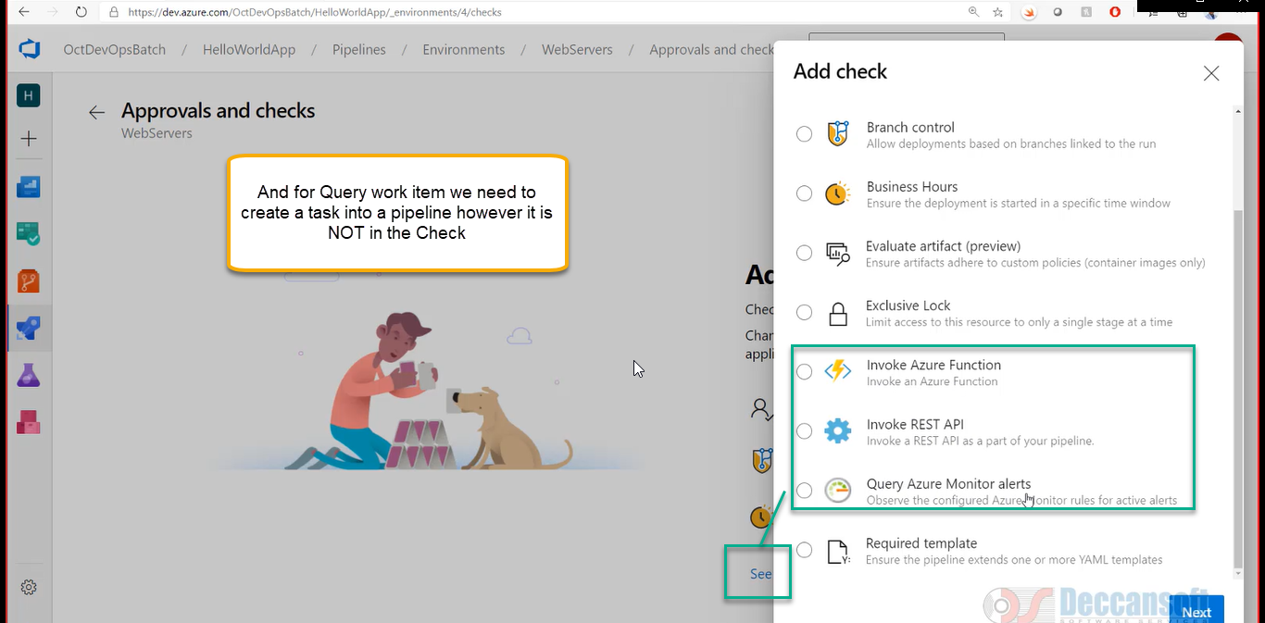

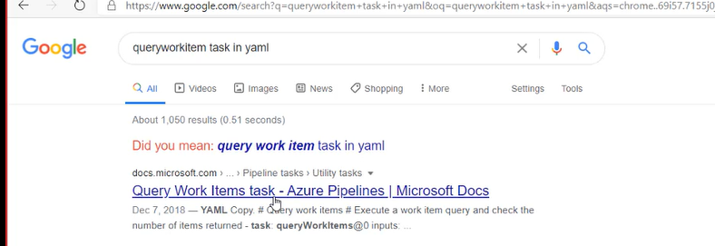

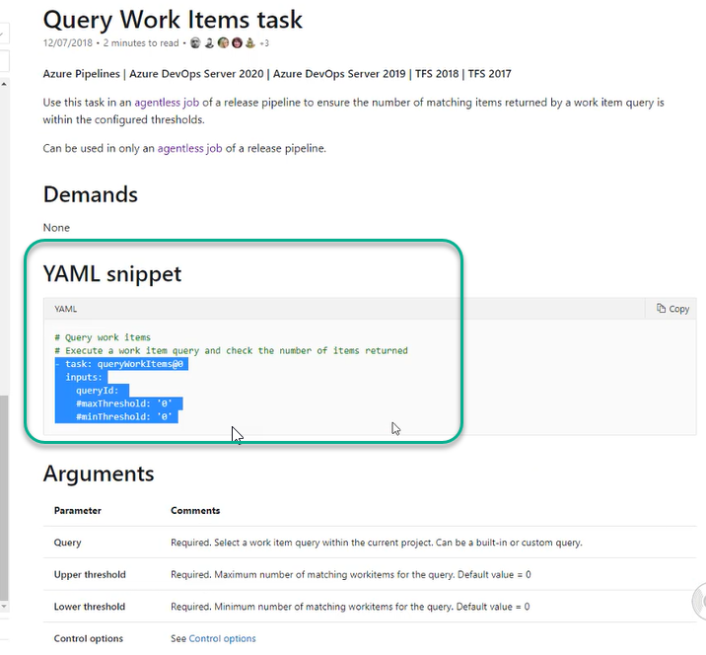

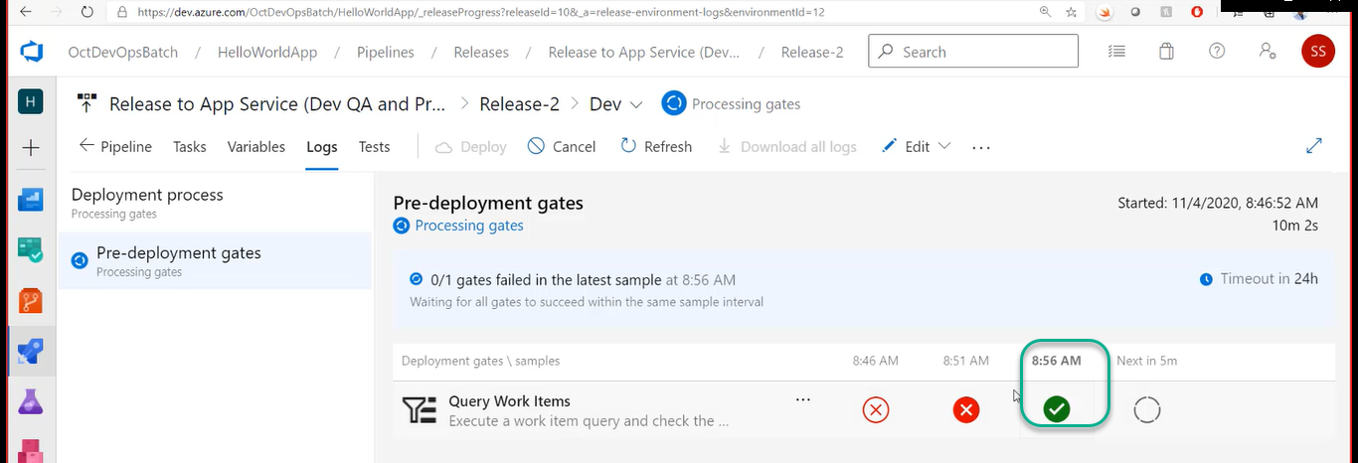

Click on <- pipeline

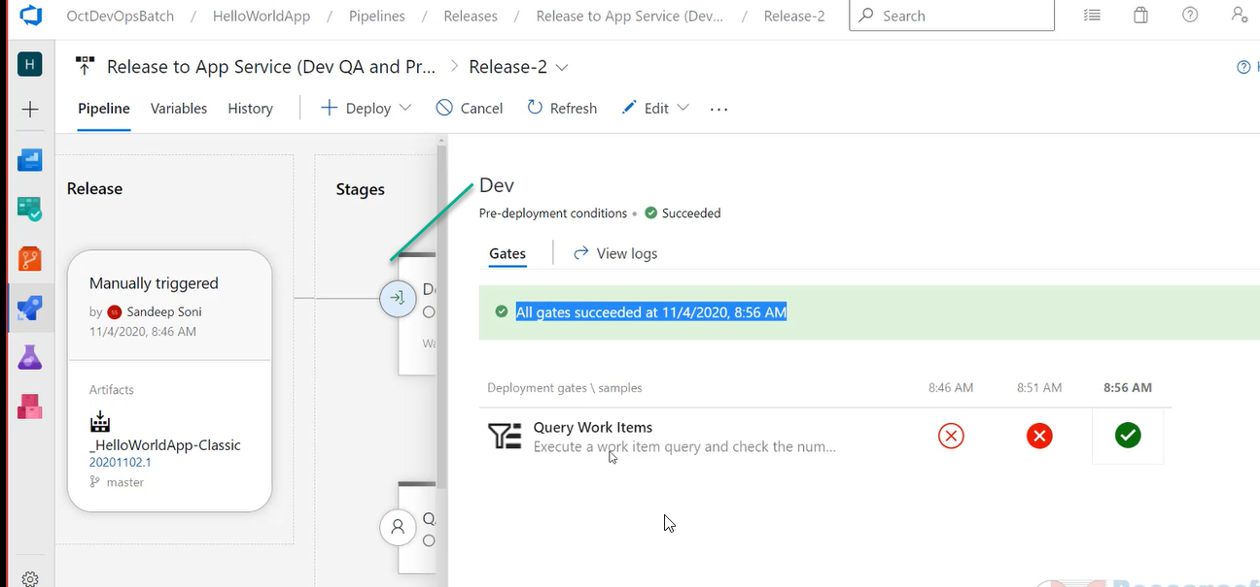

Close the Dev window

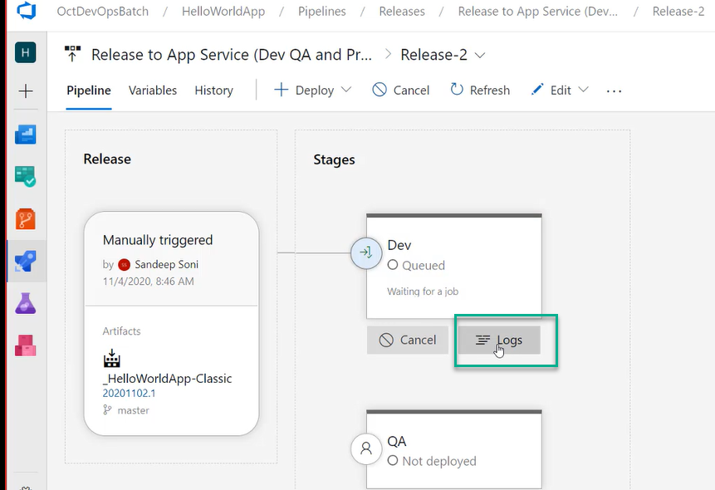

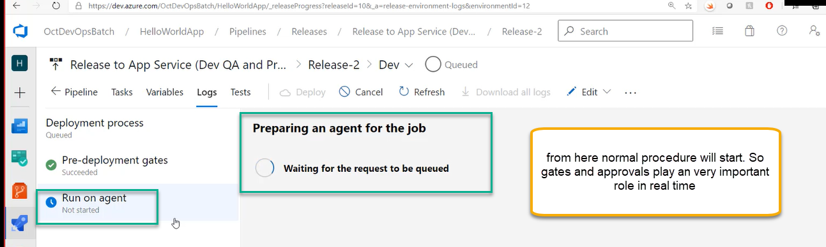

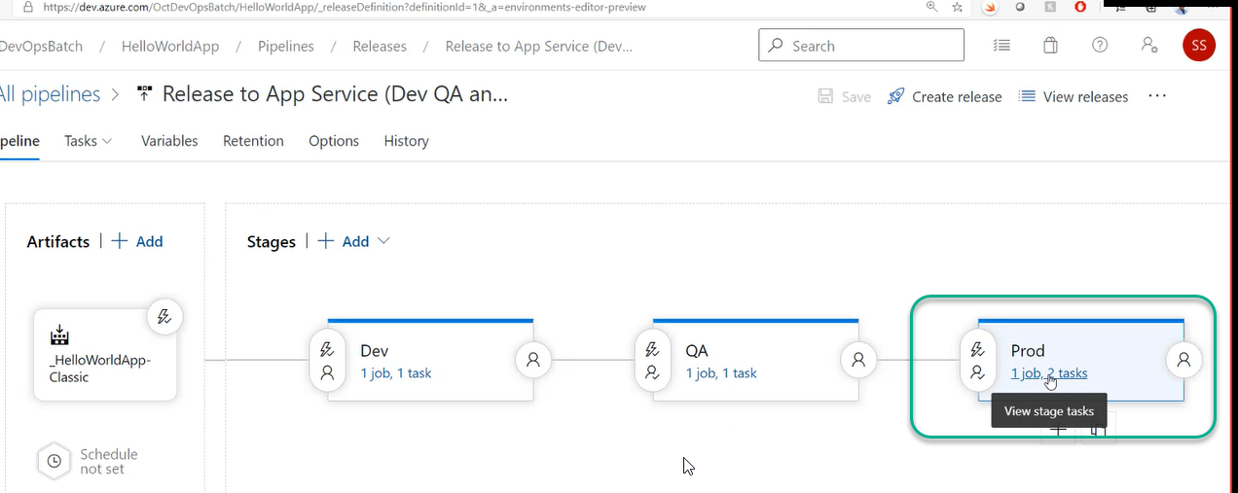

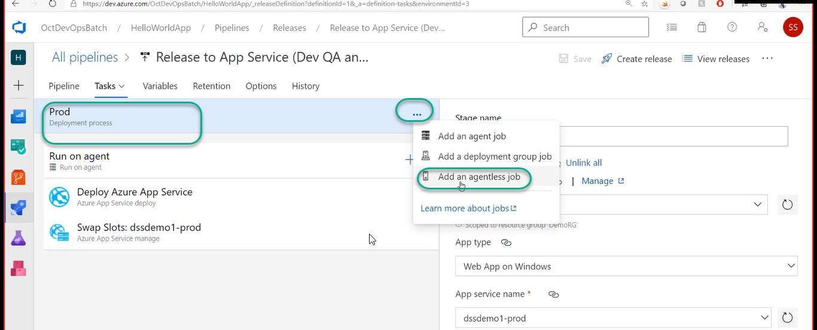

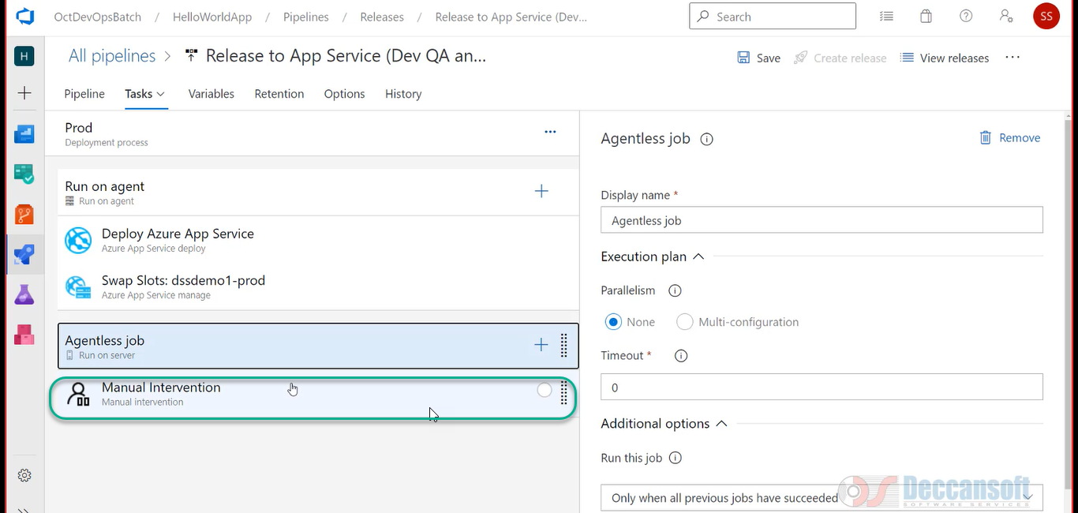

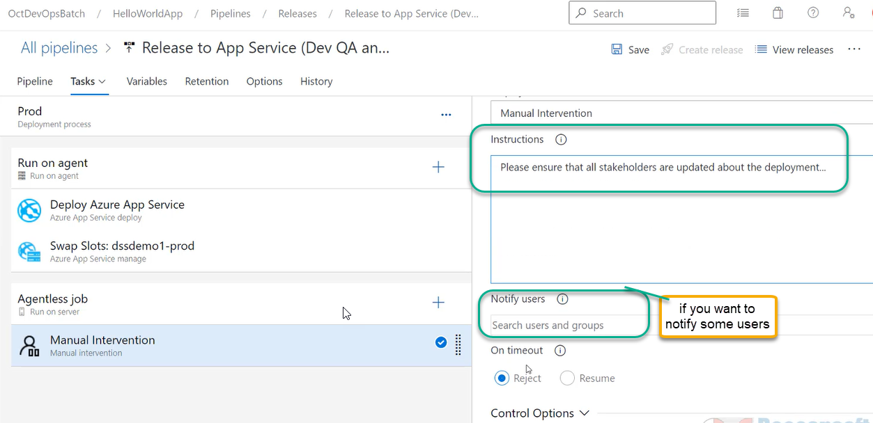

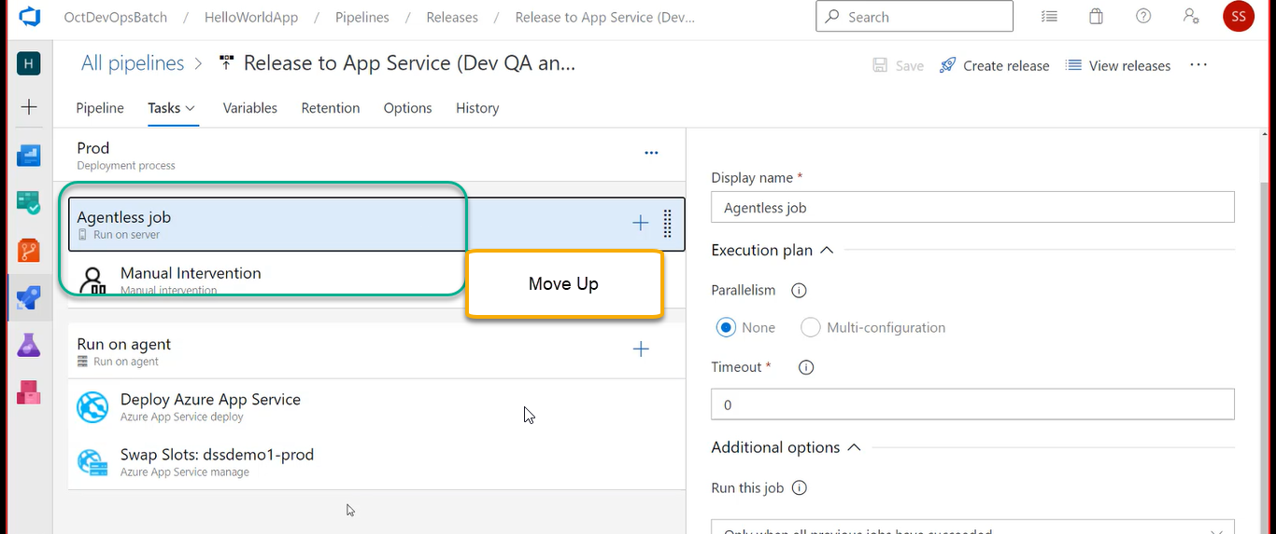

Before that disable the gates in Dev-redeployment conditions

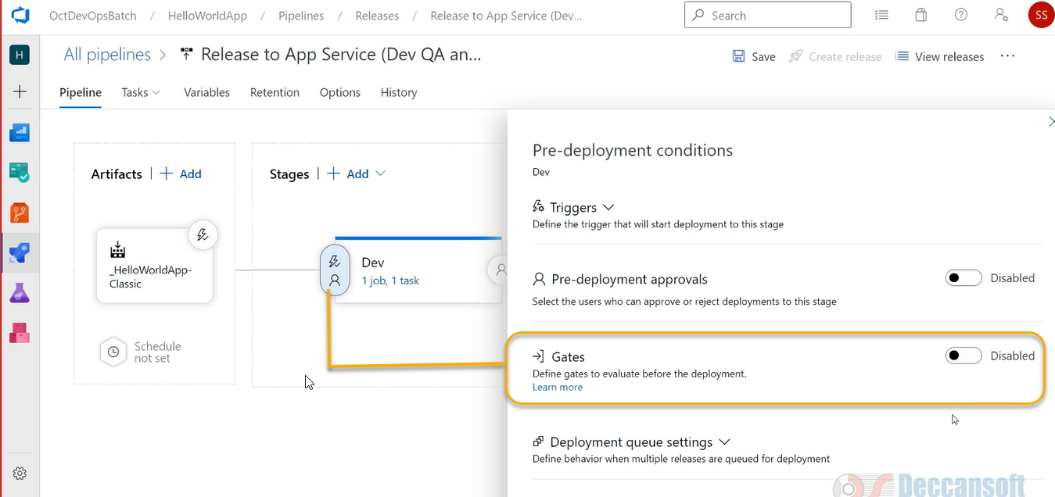

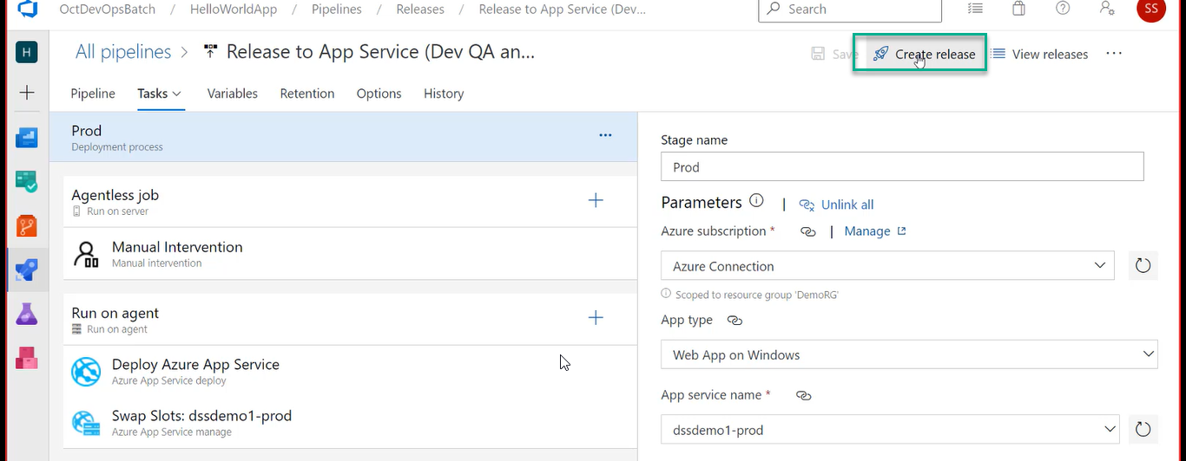

We have created a pipeline it will goes to Dev > QA > And if goes into Prod it will wait for the human intervention

Somebody has to come and click on continue button

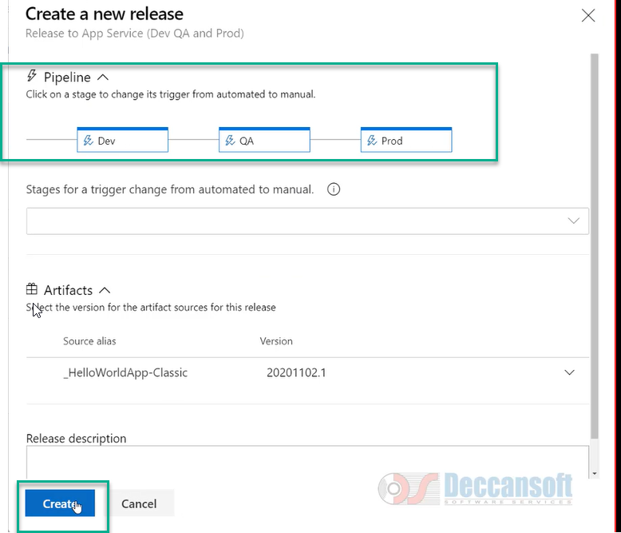

It will go to next > Acquires the agent and deploy to respective App services

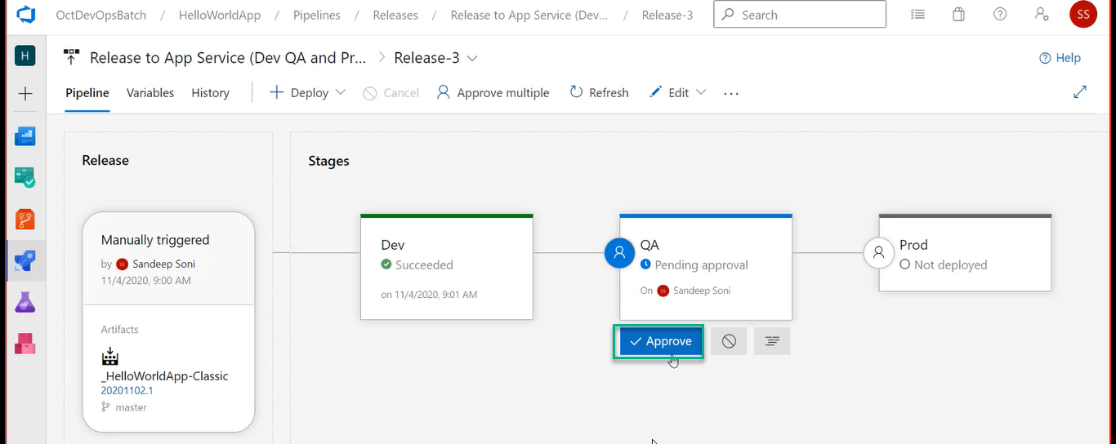

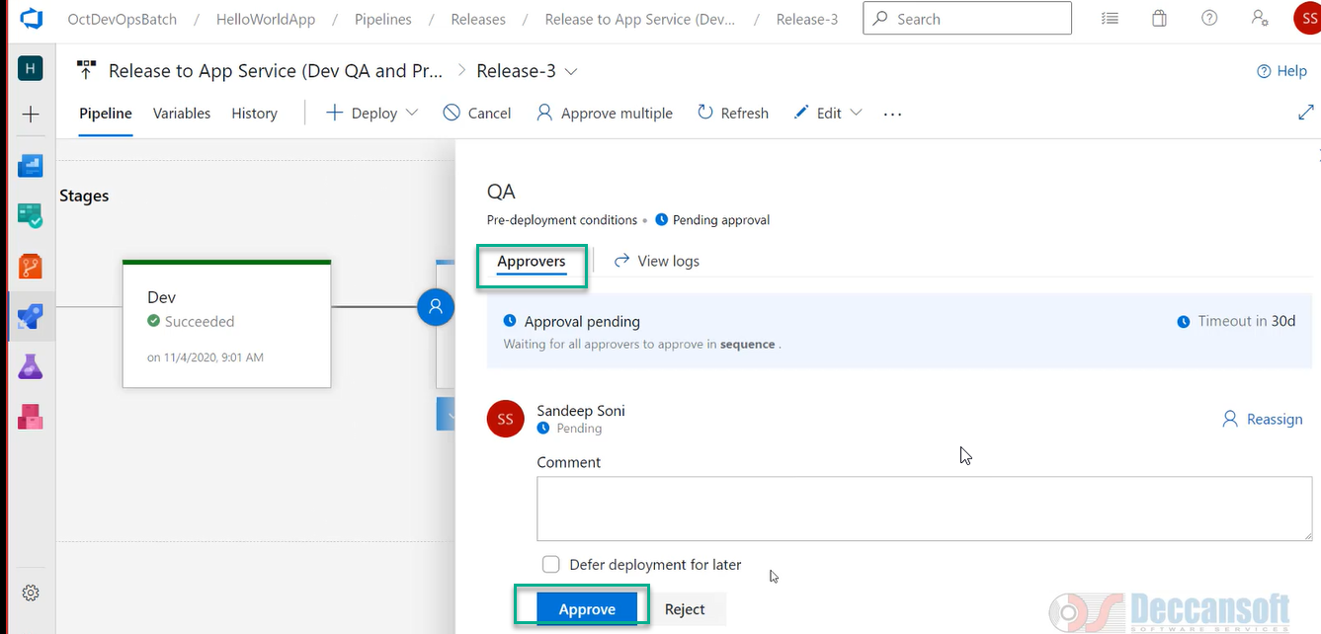

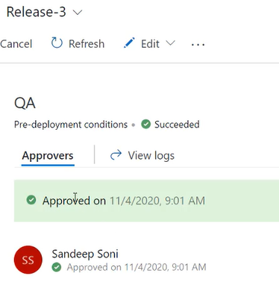

For manual intervention even if it is failing or succeed, we can click on continue the JOB will start running

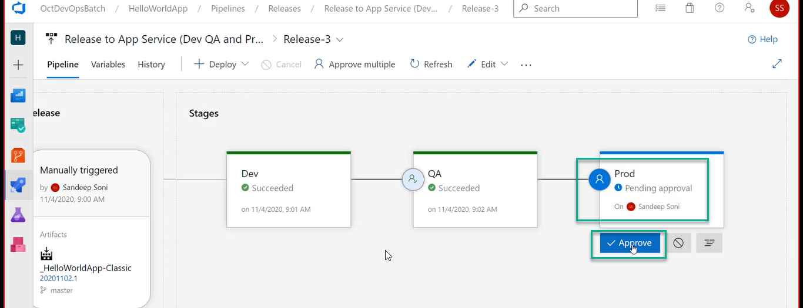

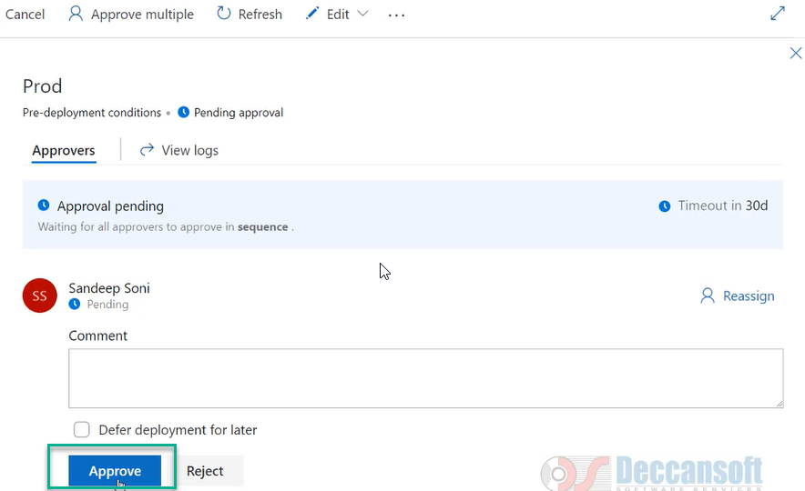

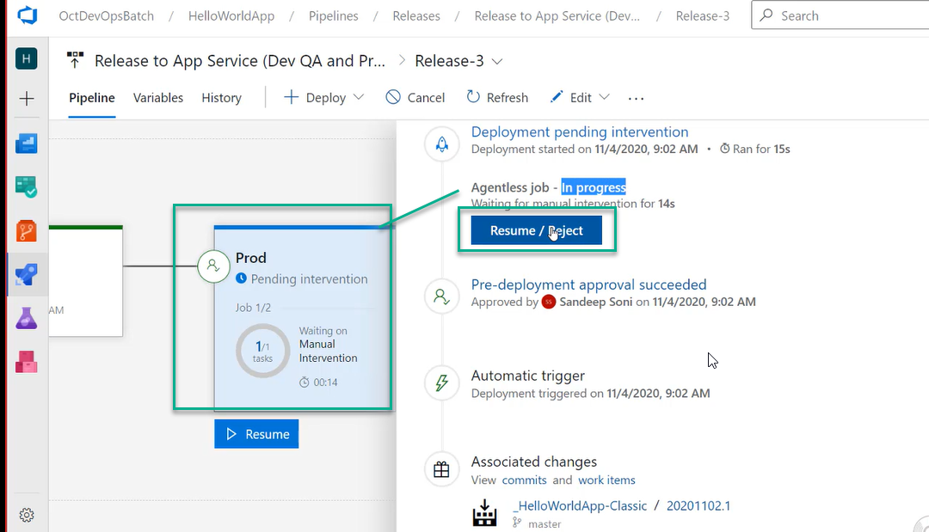

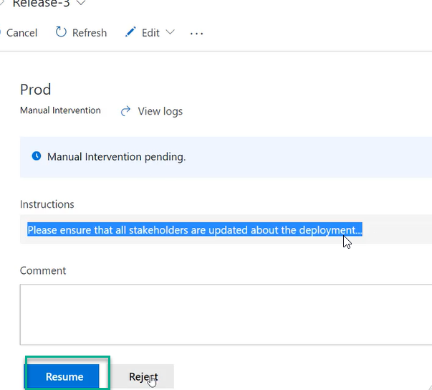

Anybody who has access to pipeline will approve it

Deploy Applications to VM using Deployment Group

Deploy ASP.NET Core App to a Windows Virtual Machine using Deployment Group

For that we need a create a VM

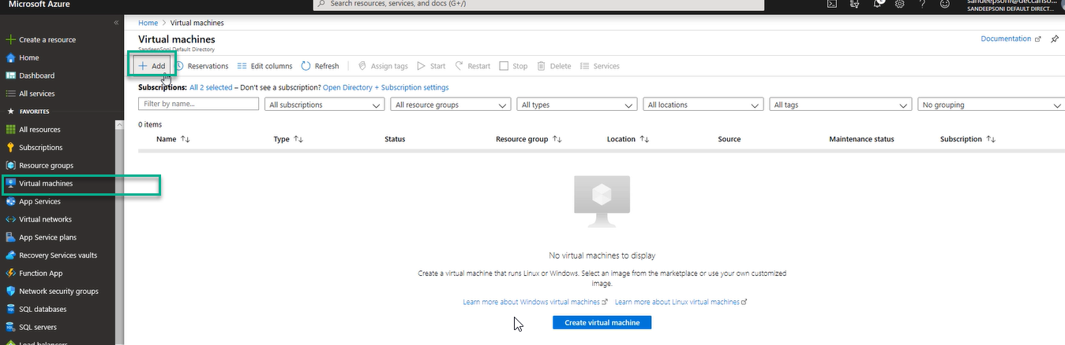

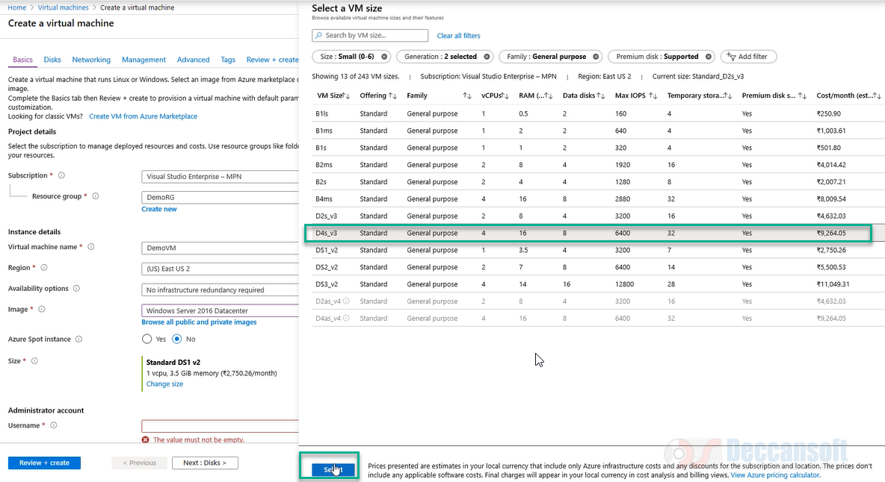

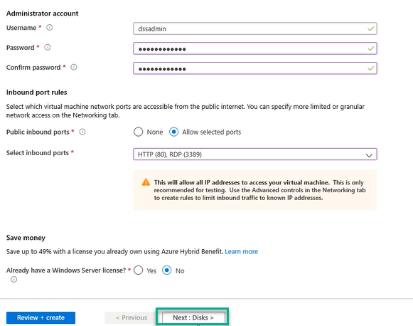

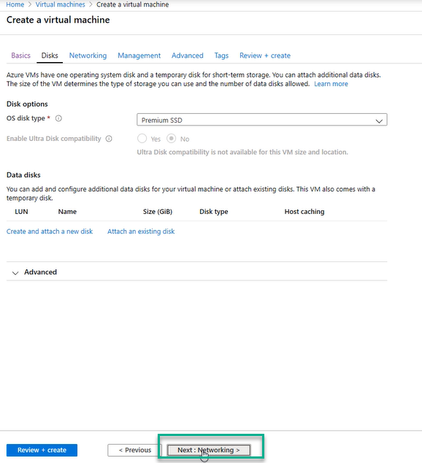

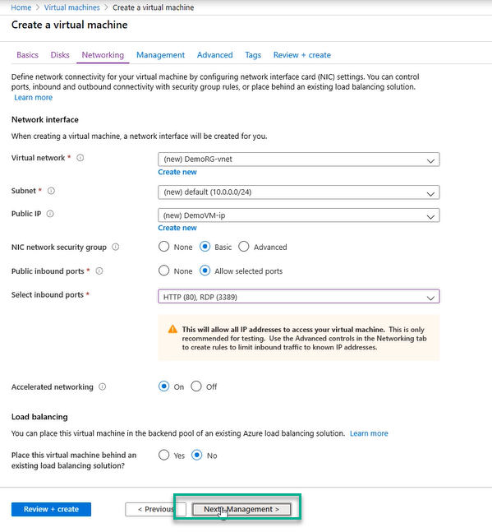

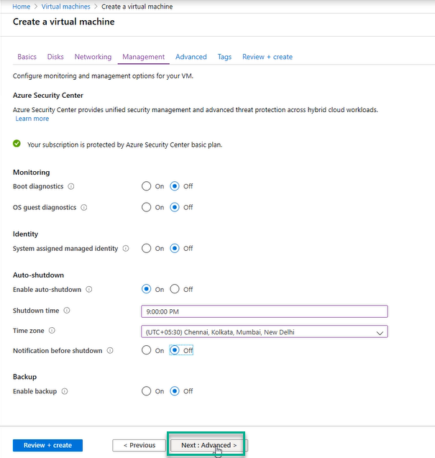

Don’t to any changes to Advanced and Click on Tags

Don’t to any changes to Tags and Click on Review and Create

Again click on Create

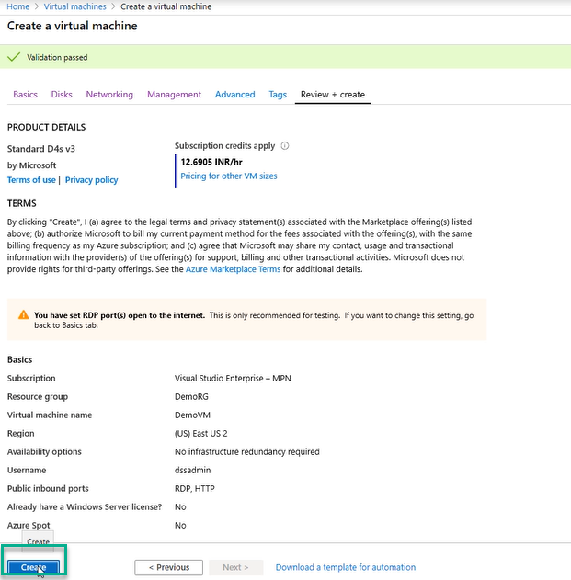

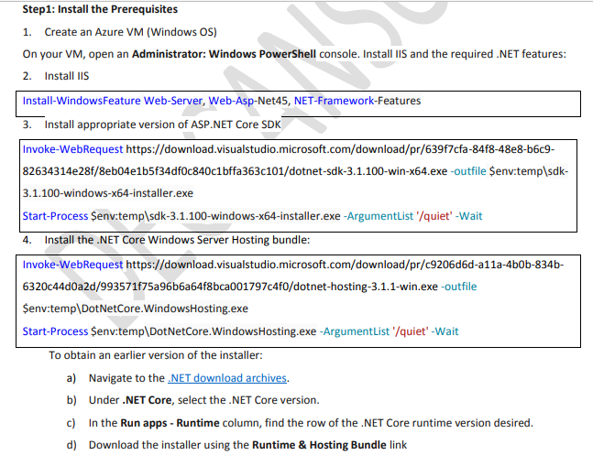

5. Restart the web server so that system PATH updates take effect

net stop was /y

net start w3svc

there might be multiple VMS where our application is going to Deploy

we may have DEV virtual machine, Test Virtual Machine, UAT VM and Production VM

Azure pipeline has to talk to VM for that In the VM we need to Install Agent software

The agent in the VM is going to take instructions from pipeline

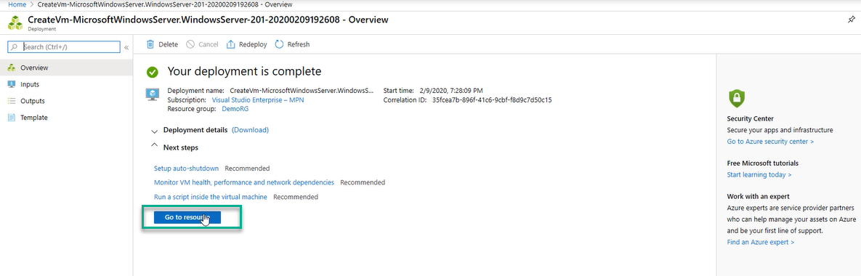

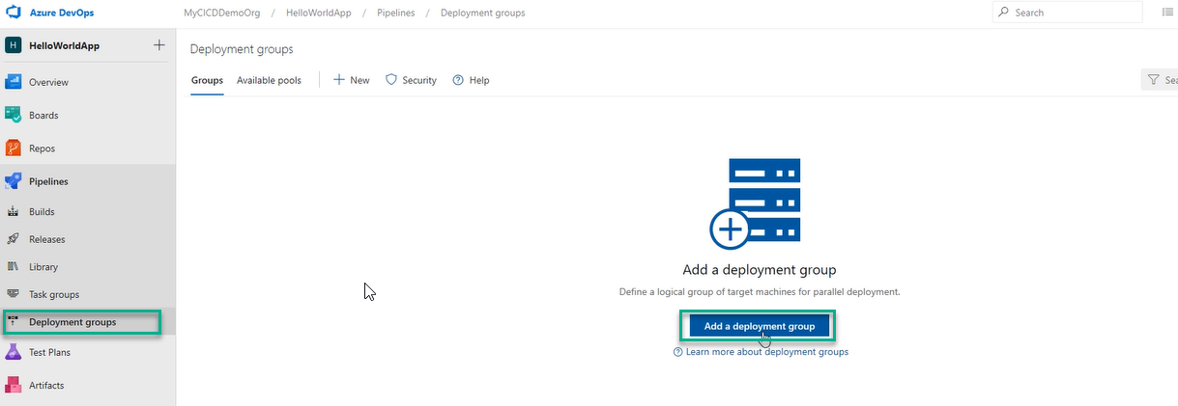

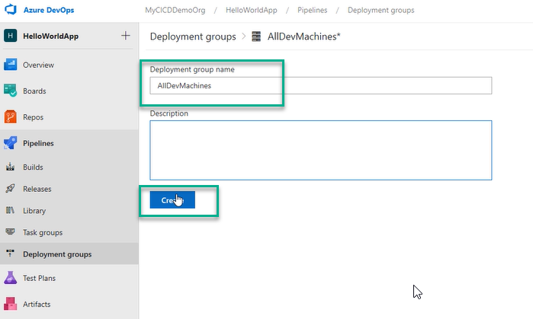

And all the machines where you want the agent to be installed

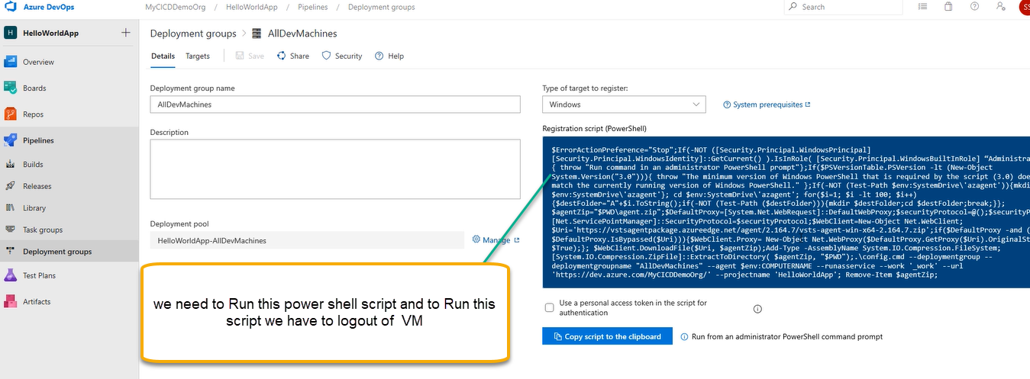

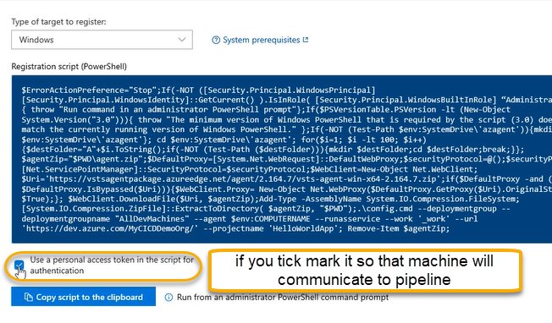

After that A PAT (Personal Access Token) token for the script for authentication is added which is identifying the current user

NOW PAT token is going to use by agent and let to connect to Azure pipeline

Agent to Connect to Azure Pipeline it will use PAT token

Usually, we are NOT supposed to tick it once the script is RUN it will ask you the PAT Token

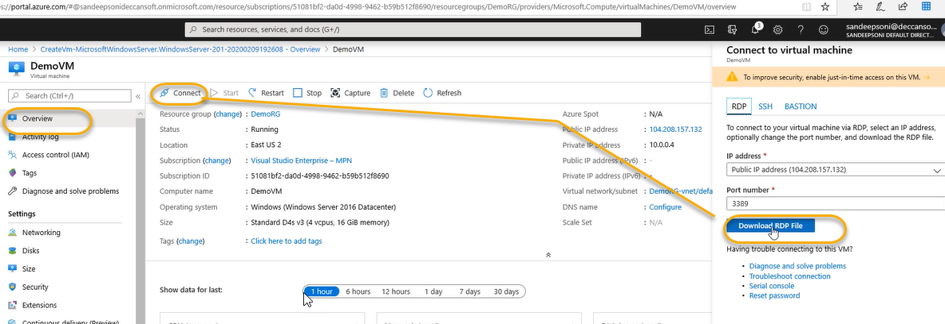

After downloading we will see the file in downloads

Open the file

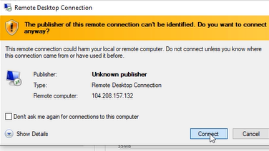

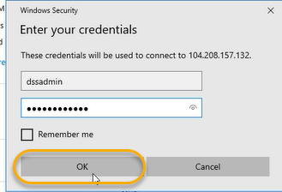

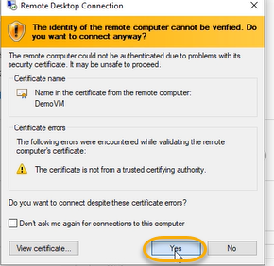

We need to execute the below commands in sequel

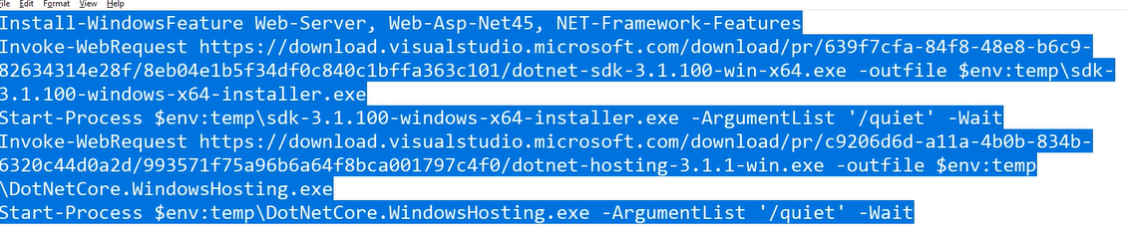

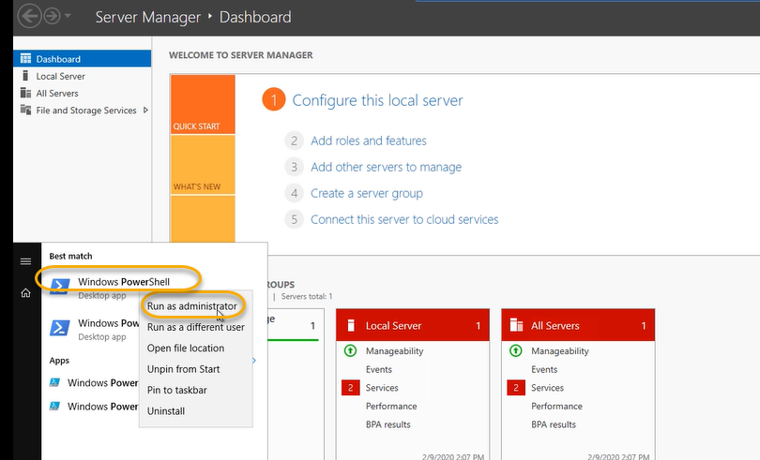

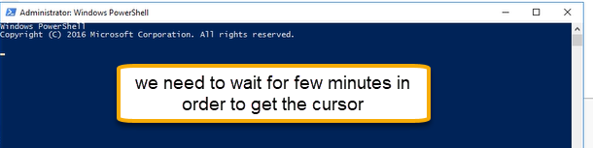

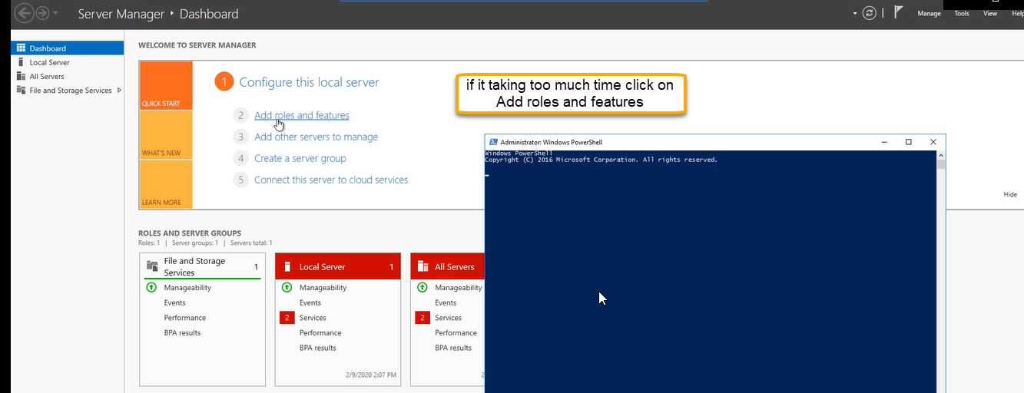

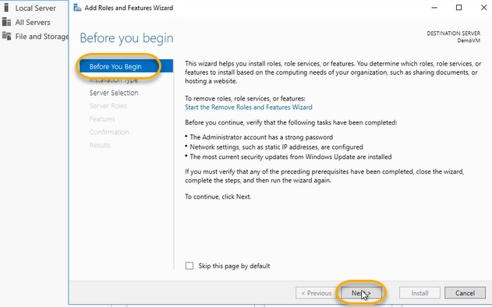

Click on Next for installation Type

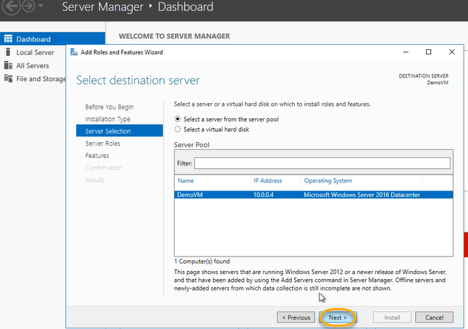

In server roles once we check in the Web server (IIS)

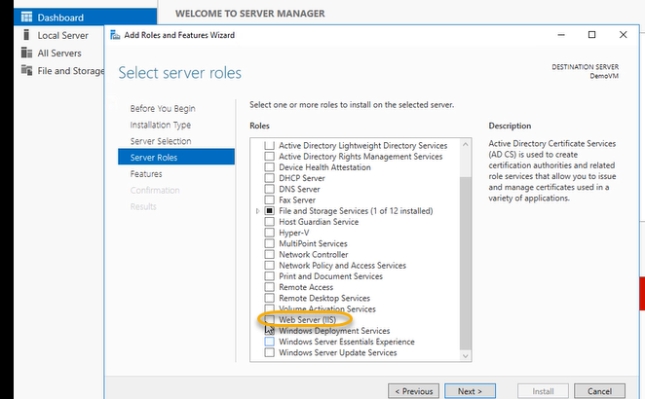

A pop up will appear for Roles and features and we see the same below

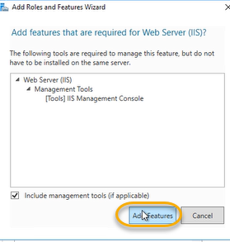

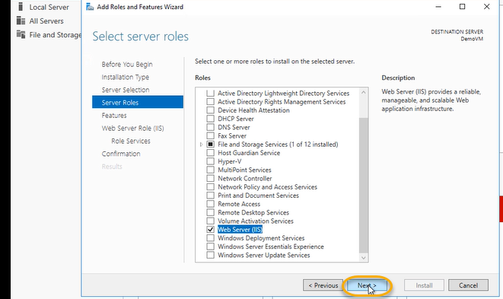

We see in the CMD a pop up has been there we can simply paste the commnads

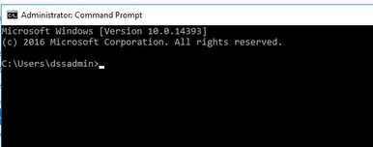

Or Paste the commands in PowerShell

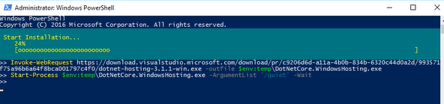

And it will start installation

Mean while we can execute the below things

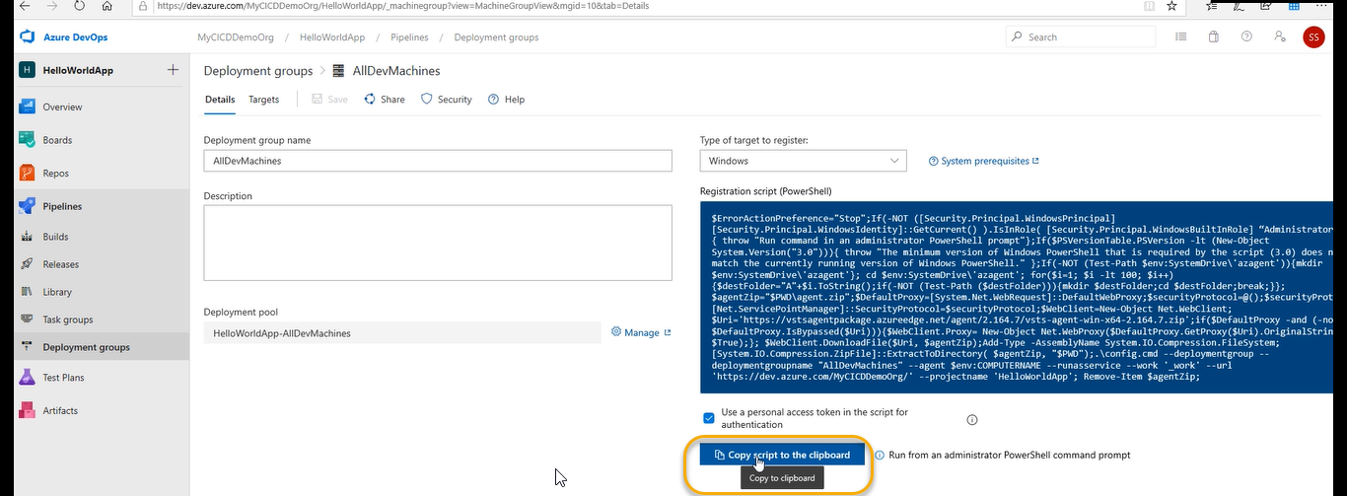

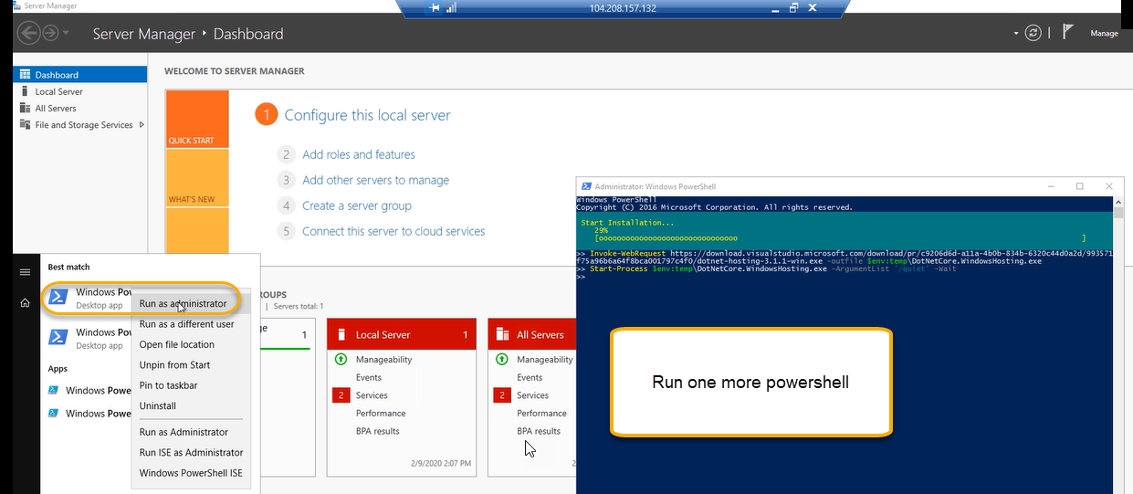

And paste it

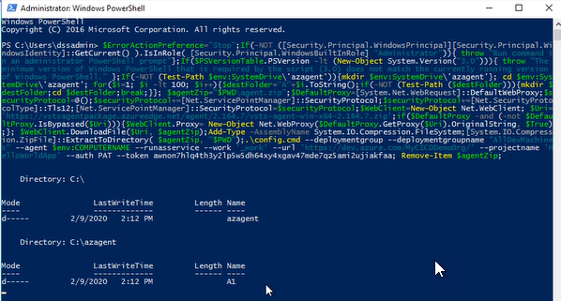

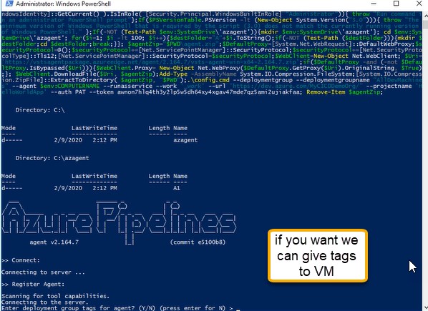

Based on tags we can filter and select and deploy to VM

If you’re NOT interested just click enter

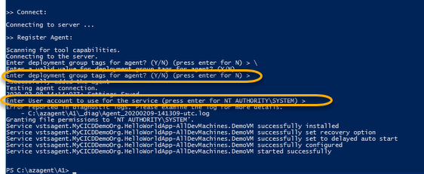

Now the agent is installed, and we can see the same in the below location

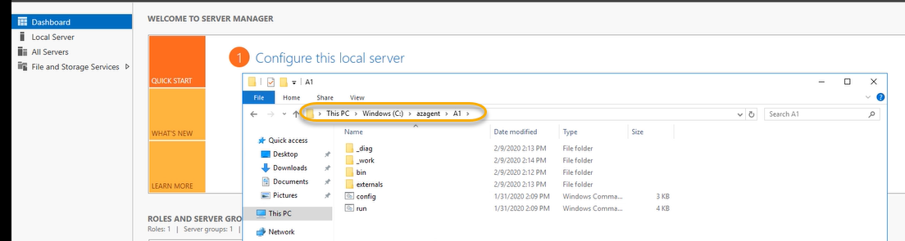

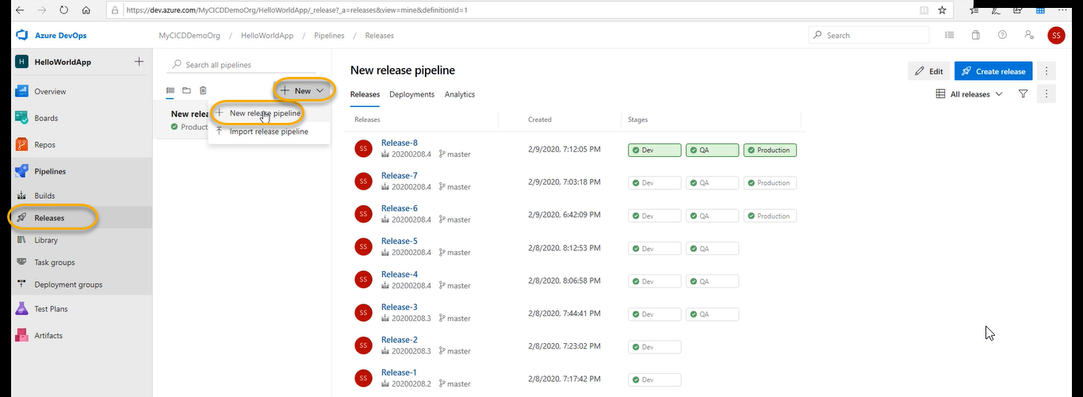

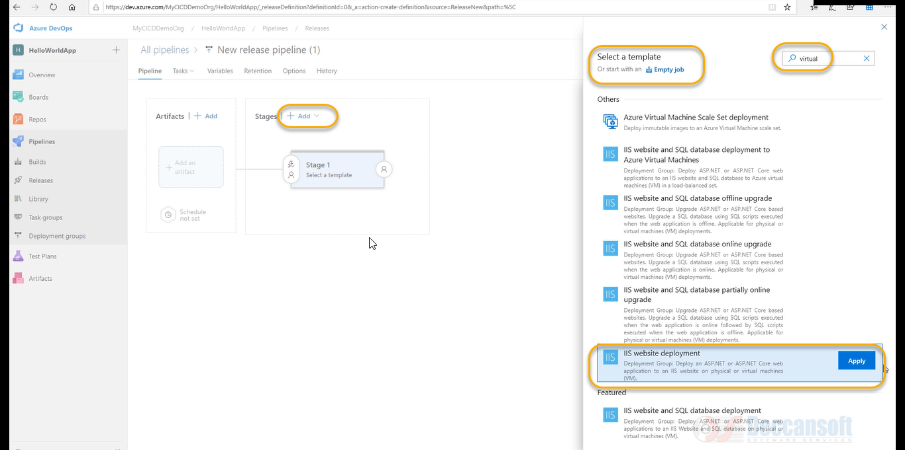

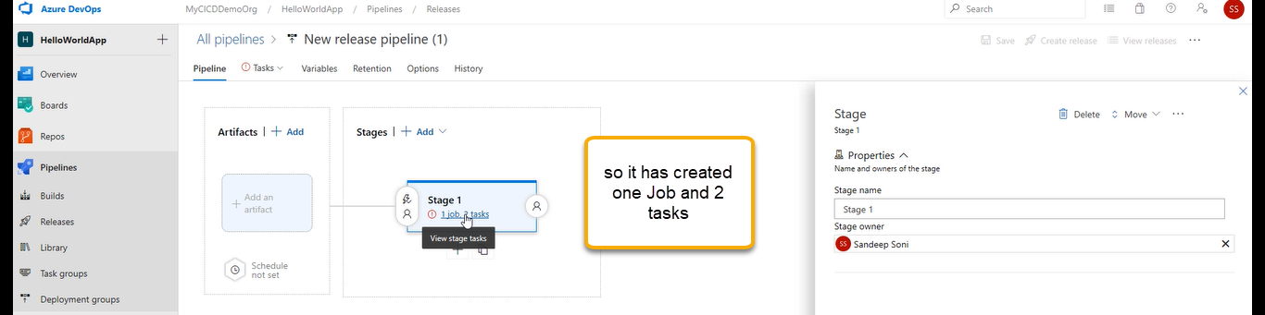

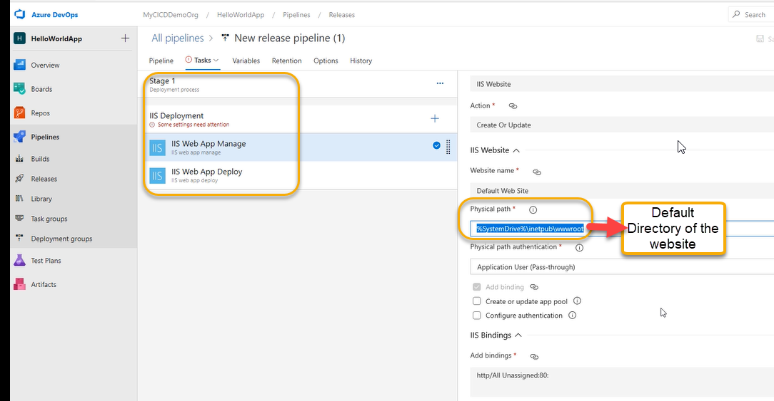

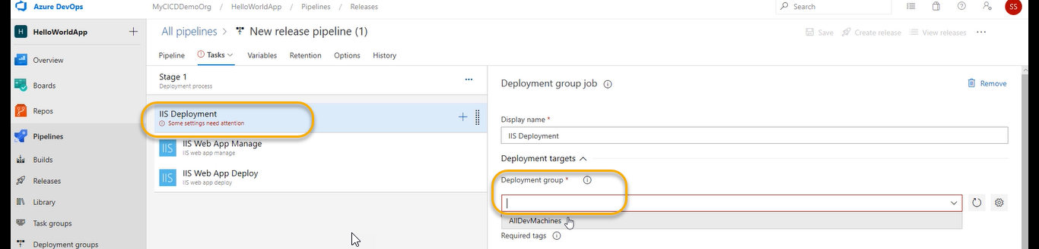

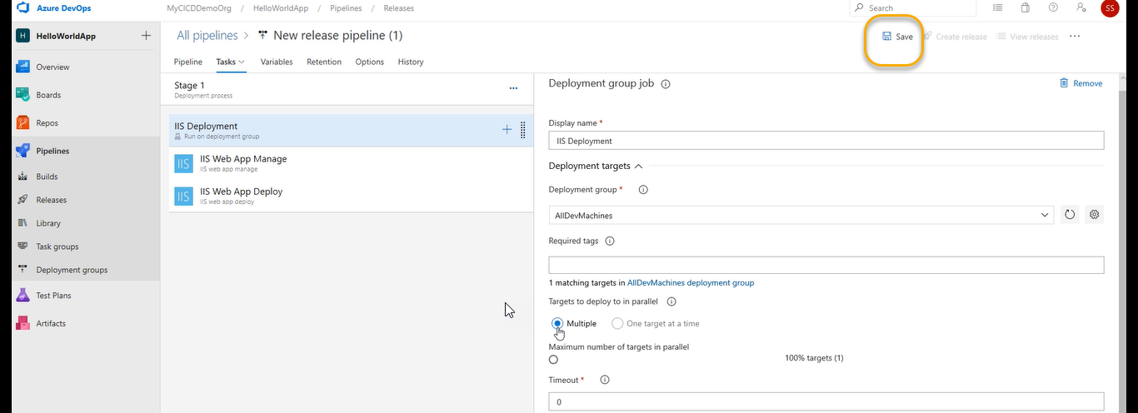

A Pop will come and again save it

Installation is done for IIS

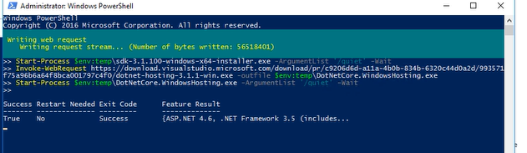

And we see the same in the below location

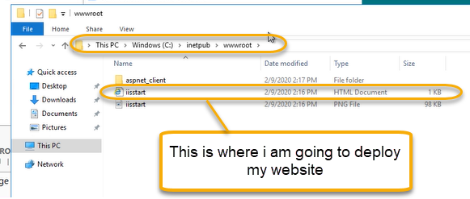

However, the complete installation is still pending

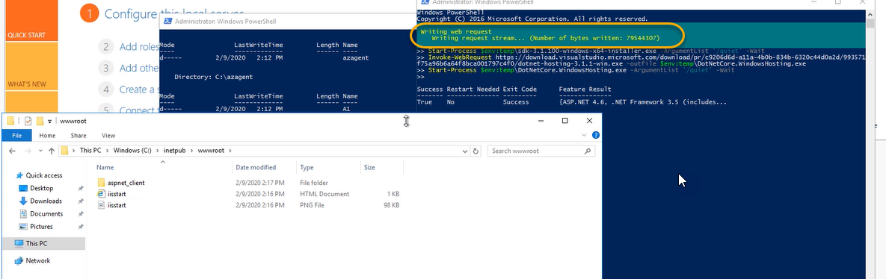

If it is NOT completed the web site will not work

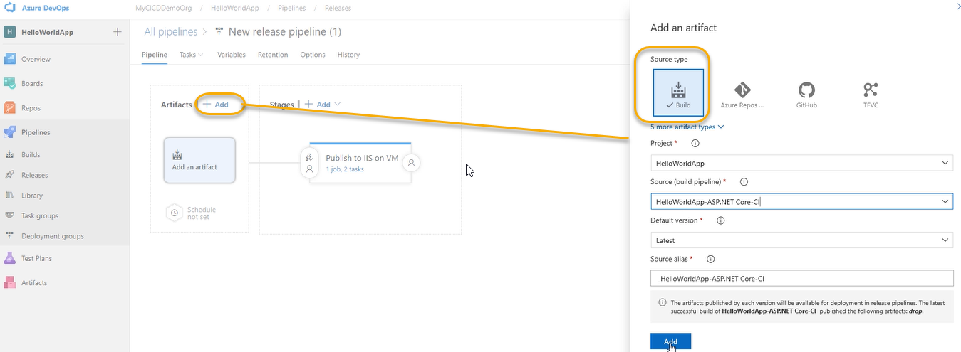

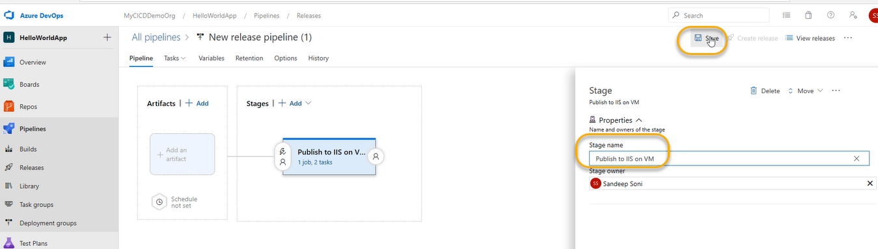

A Pop will come and again click on OK

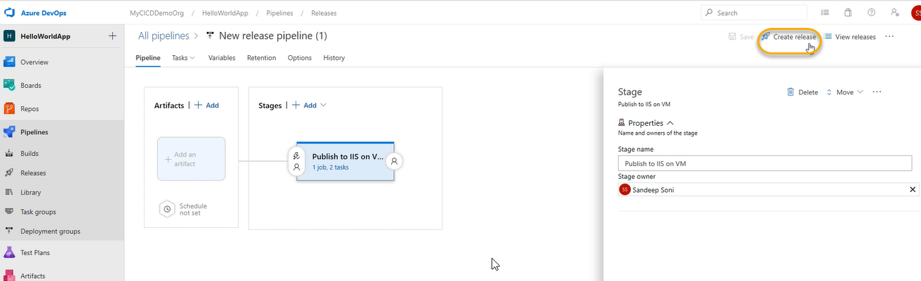

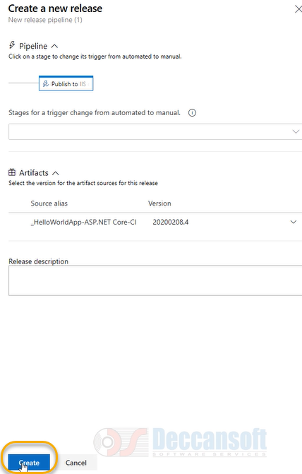

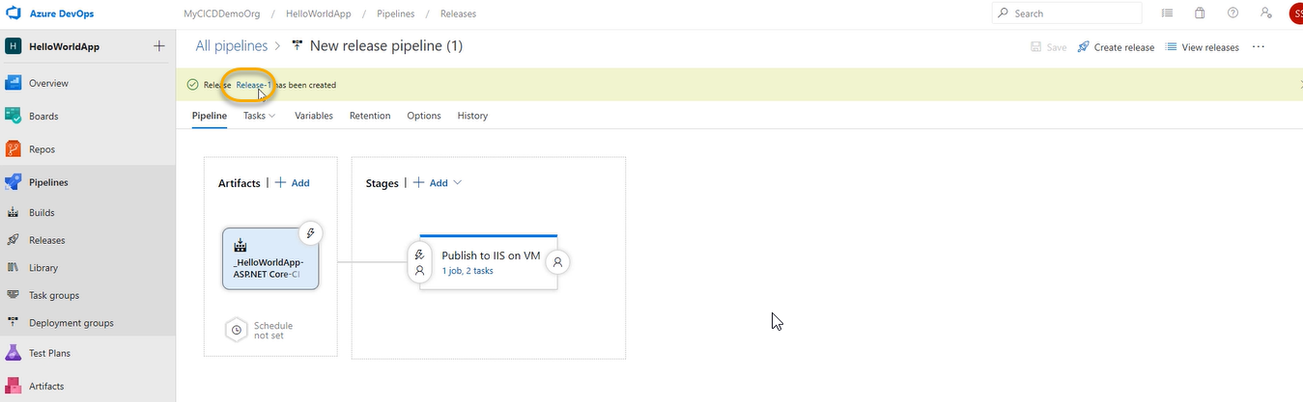

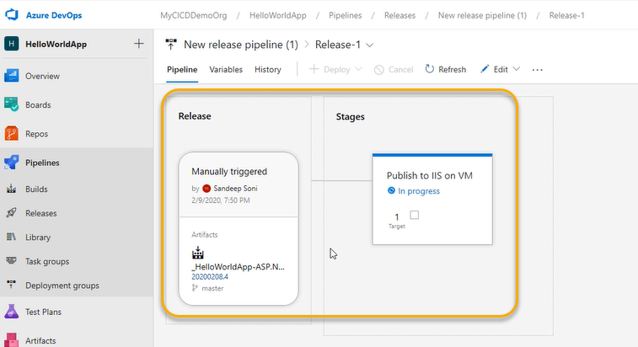

And now the above content/artifact is moving into the below location

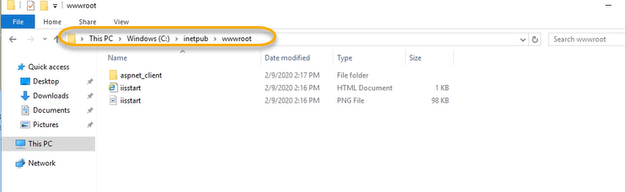

After complete finishing we can see the below ones

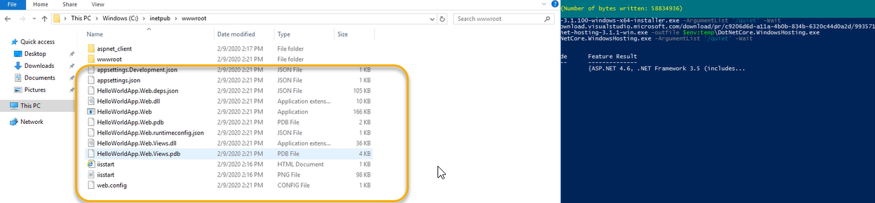

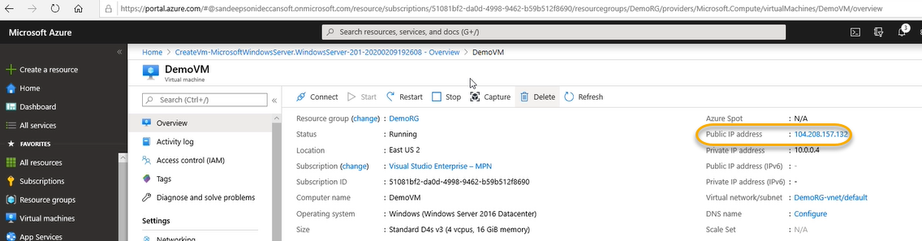

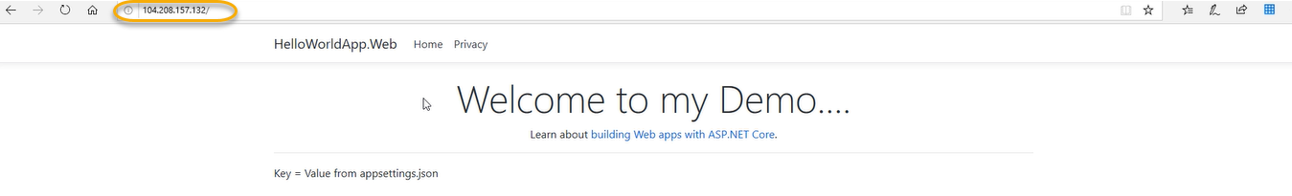

In case if you do not see the above result restart it from PowerShell

Restart the web server so that system PATH updates take effect

net stop was /y

net start w3svc

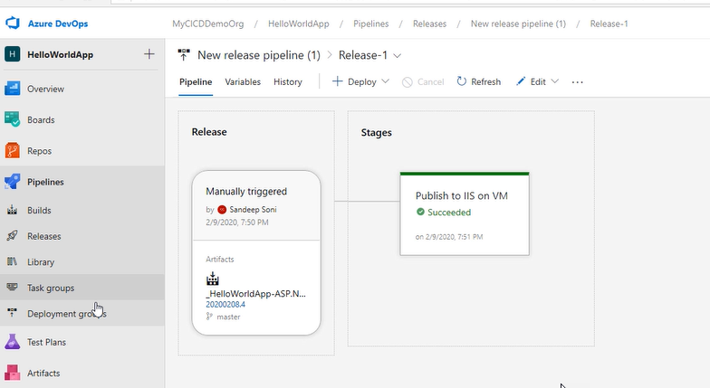

For VMS we need to go to deployment group, and it is responsible for collection of machines on which the software is supposed to install. The task which we take at the time of deployment and Job is Deployment group Job

The build artifact will tell us what type of software we are installing